


L2 User Manual

  - Safaricom Ethiopia

Unified Product Catalogue (UPC)
_________________________________________________________________________
Initial 1.0/ May 2025

Copyright
© 2025 6d Technologies. All rights reserved.
The information contained in this document is subject to change without prior notice and pertains solely to the product outlined in the introduction. This document is intended exclusively for use by 6d’s customers, under the terms of the agreement through which it has been provided. No portion of this document may be reproduced, stored, or transmitted in any form or by any means without the prior written consent of 6d Technologies.
This document is intended for use by qualified and trained professionals. The customer bears full responsibility for its application. Both this document and the associated product are protected under applicable copyright laws.
Disclaimer
The information and statements provided in this document regarding the suitability, capacity, or performance of the hardware or software products mentioned are not to be considered binding. Such specifications shall be governed exclusively by the terms of the agreement between 6d Technologies and the customer.
While 6d Technologies has made every reasonable effort to ensure that the instructions in this document are accurate and complete, the company does not warrant the absence of material errors or omissions. If required, 6d will provide clarification or additional information on matters that may not be explicitly addressed in this document.
Feedback
6d Technologies welcomes customer feedback as an integral part of its ongoing efforts to enhance and improve the quality of its documentation.
Trademarks and Registered Trademarks
The products and product names referenced in this document may be trademarks or registered trademarks of their respective owners.

Revision History
Version | Issued Date | Author | Description
1.0 | 31/08/2025 | Anoop G Nair | Draft

Table of Contents
Table of Contents 4
1. Introduction 7
1.1 Purpose of the Document 7
1.2 Target Audience 7
1.3 Scope of the Application 7
1.4 Objectives of the Handover 8
2. System Overview 9
2.1 Architecture Overview 9
3. Key Functional Modules 10
1. upc-core 10
2. Filebeat 10
3. upc-web-portal 11
4. Filebeat 11
5. cms-upc-web-portal 12
6. Filebeat 12
4. Architecture Diagrams 13
4.1 Integration Points 14
5 Kubernetes Deployment Details 16
5.1 UPC-CORE 16
5.1.1 Overview 16
5.1.2 Summary 17
5.2 UPC WEB PORTAL 18
5.2.1 Overview 18
5.3 CMS-UPC WEB PORTAL 20
5.3.1 Overview 20
6 Microservices Overview & Configurations 22
6.1 upc-core 22
6.1.1 upc-core 22
6.1.2 Filebeat 27
6.2 upc-web-portal 29
6.2.1 upc-web-portal 29
6.2.2 Filebeat 34
6.3 cms-upc-web-portal 35
6.3.1 cms-upc-web-portal 35
6.3.2 Filebeat 40
7 Keycloak Integration 43
7.1 SSO Authentication Flow 43
7.2 Keycloak Client Configuration Highlights 44
7.3 Roles and Scopes Management 44
7.4 Fine-Grained Access Control Configuration 45
7.4.1 Key Concepts 45
7.4.2 Step-by-Step: Configuring Fine-Grained Access 45
7.4.3 Mapping Reference Sheet 48
8 Database & Persistence 49
8.1 Database Overview 49
8.2 Table Definitions 49
8.3 DB Server Details 49
8.4 DB User Credentials 49
8.5 Safe Execution of Read-Only Queries 50
8.6 DB Backup & Archiving 52
8.6.1 MySQL Enterprise Backup (MEB) – Cluster-Level Snapshot 52
8.6.2 Table Dump before any Configuration – Fine-Grained Recovery 53
9 CI/CD & Deployment 54
9.1 Overview 54
9.2 Deployment Workflow Overview 54
9.2.1 Git Extension Setup on Local Machine (L2) 54
9.2.2 L2 Image Retrieval and Internal Registry Push 57
9.2.3 Sync via ArgoCD 58
9.2.4 Validation After Deployment 59
9.2.5 Manual Git-Based Deployment (Fallback – Jump Server) 59
9.3 References and Access Details 60
10 Logging, Monitoring, and Management 62
10.1 Log Storage Overview 62
10.2 Accessing Logs from Jump Servers 62
10.3 Log Backup and Housekeeping Script 62
10.4 Current Log Retention Policy 63
10.5 Monitoring and Alerting 63
10.5.1 Prometheus Metrics Endpoints 63
11 Troubleshooting Guide 65
11.1 General Troubleshooting Approach 65
11.2 Log Access Paths 65
11.3 Log Analysis – Tracking Requests 66
11.3.1 Tracking GET Requests from 3rd Parties to upc-core 66
11.4 Common Kubernetes Troubleshooting Commands 67
12 UPC Unresponsiveness Due to NFS Mount Slowness 67
12 Steps to take Heap & Thread Dump 69
12.1.1 Heap Dump Collection 69
12.1.2 Thread Dump Collection 70
13 Operational Tasks 71
4.1 BS CATEGORY MASTER Manual Data Addition 71
4.2 bs_service_offering_master Manual Data Addition 71
4.2 SLM_GENERAL_DROP_DOWN_DETAILS Manual Data Addition 72
14 L2-to-L3 Escalation Procedure and SLA Guidelines 73
14.1 Purpose 73
14.2 Escalation Workflow 73
14.2.1 L2 Diagnosis 73
14.2.2 Submit Escalation to 6d Support 73
14.2.3 L3 Assignment 74
14.2.4 Template Verification 74
14.3 Prerequisites Before Escalation 74
14.4 Incident Severity Classification (P1-P4) 75
14.5 Ticket Hold & Auto-Closure Policy 75
14.6 Post-Escalation Handling 75
15 Appendices 76
15.1 API Request & Response Reference 76
15.1.1 Fetch Family details 76
15.1.2 View all language mapping of plans 76
15.1.3 View all language mapping against the plan IDs 76
15.1.4 Fetch details with Product ID 76
15.1.5 Fetch plans with Filters and Parameters 77
15.2 APIs called from UPC 77
15.2.1 Towards NMS to Fetch shortcodes [refer logs for more info]: 77
15.2.2 Towards Mo-Router to Insert the SDP plan details [refer logs for more info]: 77
15.3 PO Creation Flow 78
15.4 Important Plan Characteristics 82
15.4.1 CFSS_UPC: 82
15.4.2 CFSS_NCC: 83
15.4.3 CFSS_SM_STD: 83

Introduction

Purpose of the Document
This document serves as a comprehensive technical handover guide for the Unified Product Catalogue (UPC) Application deployed in a Kubernetes-based production environment. It is intended to enable L2 support engineers to independently manage, monitor, and troubleshoot the application, ensuring continuity of operations with minimal dependency on the development team.
The document outlines all critical components, configurations, and operational procedures required to support the UPC application. It also includes essential information about microservices, logging, authentication, database interactions, deployment pipelines, and integration points with other systems.

Target Audience
This documentation is specifically designed for:
- L2 Operations Engineers
- Monitoring Teams
The content assumes a working knowledge of Kubernetes, MySQL, microservices architecture, and basic Linux system administration & Shell Scripting.

Scope of the Application
The Unified Product Catalogue (UPC) system is a telecom-grade application responsible for handling the product (bundle) related details, such as Marketing description, Price to display, Language mappings, the Rules for the bundle purchase etc. The UPC application is capable of handling multiservice offerings with multi-tiered pricing structures; this is the place where all service differentiation is realized. The system supports all kinds of networks such as GSM, fixed-line, broadband, and so on. The key responsibilities of the application include:
- Configuring the plans based on the business requirement.
- Configuring the prices to display at the subscriber endpoints.
- Configuring the language mappings to display the plan details based on the subscriber preferred language.
- Configuring the parameters to fetch the bundles based on the business rules.
- Integrating with applications such as APIGW, CRM, COM, SDP, SM, NMS, SLM, KeyCloak, UMS.
- Responding to the fetch requests based on the Rules configured in each plan.
This document covers the entire ecosystem surrounding the UPC application, including:
- Application architecture and components.
- Kubernetes deployment model and scaling behaviour.
- Configuration files.
- Database schema overview and data flow.
- CI/CD deployment process.
- Monitoring and logging via Filebeat, Kafka, Splunk & Shell scripts.
- Known issues and troubleshooting guidelines.

Objectives of the Handover
- Ensure operational readiness of the L2 support team.
- Transfer complete knowledge of application deployment, configuration, and maintenance.
- Establish self-sufficiency in handling incidents and performing standard operations.
- Document all integration touch points and recovery mechanisms.

System Overview
The Unified Product Catalogue (UPC) application is an enterprise-grade platform designed to facilitate the creation, modification of plans based on the business requirements. It enables the subscribers to fetch the plans based on their requirements and eligibility as the plans are segregated based several parameters such as Network Type, Connection type, Customer Category etc. through modular and scalable microservices architecture.

Architecture Overview
The Unified Product Catalogue (UPC) system is deployed on a Kubernetes (K8s) cluster using an active-active architecture across two geographically separated sites—ED2 and MDC1. This setup ensures high availability, disaster resilience, and load distribution across environments.
Deployment and configuration management follow a GitOps-based approach, leveraging Argo CD for the synchronization of infrastructure and application states directly from version-controlled repositories. This ensures consistency, auditability, and secure delivery of changes across both environments.
The application is logically structured as a single upc-core primary Kubernetes pod and UPC & SDP(cms) web-portal pods which holds the same upc-core applications, each responsible for a distinct set of functionalities:
- Upc-core: Hosts core APIs like Create/Modify/Delete and Product fetch.
- Upc-web-portal: This is the UI application from where the user can do create/modify/delete BSS plans and its related details based on the requirements.
- Cms-upc-web-portal: This is the UI application from where the user can do create/modify/delete SDP plans and its related details based on the requirements.
Each pod has one microservice and is often paired with a Filebeat sidecar container. Filebeat is used for:
- Shipping structured and multiline logs to Kafka.
- Exporting CDRs to designated directories or Kafka topics for mediation and reporting [Here UPC doesn’t have a concept of writing CDRs].
This modular and containerized architecture allows for scalability, independent lifecycle management, and better resource isolation across UPC components.

The UPC system is modularized into three primary pods, each responsible for a distinct set of functionalities. The microservices are distributed across the pods as outlined below:
Pod Name | Microservices
upc-core | upc-core
 | filebeat
upc-web-portal | upc-web-portal
 | filebeat
cms-upc-web-portal | cms-upc-web-portal
 | filebeat

3. Key Functional Modules
Below are the key functional modules of UPC applications.

upc-core
The upc-core module serves as the core backend engine of the Unified Product Catalogue (UPC) application. It is primarily responsible for performing the create/modify/delete/fetch plans and the related details based on the business requirements.
This microservice acts as the main interface between the UIs (upc-web-portal/cms-upc-web-portal) and the backend, handling most of the real-time user interactions. All product related actions initiated by users—whether manual or automated—are routed through upc-core.
As a foundational module, it integrates with several other UPC components, including:
- Database layer (via configured JNDI datasource)
- User and configuration services for validation and metadata enrichment
- Audit services to maintain end-to-end visibility and compliance
- External systems, such as CRM or 3rd party platforms, where applicable
The service is designed to be stateless and scalable, ensuring high performance and consistency across distributed deployments in the active-active architecture.

Filebeat
The filebeat container is responsible for collecting and forwarding application logs from multiple UPC microservices to a centralized Kafka topic. This enables real-time log aggregation, monitoring, and long-term retention through downstream logging platforms such as ELK or Splunk.
This container is deployed as a sidecar in several UPC pods (e.g., upc-core, upc-web-portal, cms-upc-web-portal) and is configured to:
- Tail log files generated by various UPC modules, including core and web-portal UI services.
- Use a multiline pattern to correctly group multi-line log entries such as stack traces or structured logs.
- Tag logs dynamically with a Kafka topic field to enable accurate routing and classification.
- Stream logs to Kafka using secure SASL authentication, with support for compression and partitioning to ensure scalability and efficiency.
This setup ensures:
- Consistent and structured log formatting
- Seamless observability across services
- Centralized log availability for alerting, troubleshooting, and compliance auditing

upc-web-portal
The upc-web-portal is the user interface (UI) microservice of the Unified Product Catalogue (UPC) application specifically for BSS. It provides the primary front-end interface through which end users interact with the system to perform essential operations such as creating, updating, viewing, and managing products and its related configurations.
Designed for usability and responsiveness, the upc-web-portal abstracts the underlying business logic and offers a streamlined experience tailored to different user roles. It communicates with the business logic service,
- Upc-core for product operations

The portal also integrates tightly with Keycloak, the UPC system’s identity and access management solution. It handles:
- Authentication via secure redirection to Keycloak login pages
- Token validation for securing access to APIs
- Role-based access control (RBAC) to ensure users can only access UI features and data permitted by their assigned roles
Through this microservice, users can efficiently interact with product, dashboards, configurations menus of the UPC system in a secure and intuitive environment.

Filebeat
The filebeat container is responsible for collecting and forwarding application logs from multiple UPC microservices to a centralized Kafka topic. This enables real-time log aggregation, monitoring, and long-term retention through downstream logging platforms such as ELK or Splunk.
This container is deployed as a sidecar in several UPC pods (e.g., upc-core, upc-web-portal, cms-upc-web-portal) and is configured to:
- Tail log files generated by various UPC modules, including core and web-portal UI services.
- Use a multiline pattern to correctly group multi-line log entries such as stack traces or structured logs.
- Tag logs dynamically with a Kafka topic field to enable accurate routing and classification.
- Stream logs to Kafka using secure SASL authentication, with support for compression and partitioning to ensure scalability and efficiency.
This setup ensures:
- Consistent and structured log formatting
- Seamless observability across services
Centralized log availability for alerting, troubleshooting, and compliance auditing

cms-upc-web-portal
The cms-upc-web-portal is another user interface (UI) microservice of the Unified Product Catalogue (UPC) application not specifically for SDP plans but this UI is integrated with CMS as well since the same UI is used for performing the CMS related changes. This acts same as the upc-web-portal, and the only difference is that we use this UI for creating VAS plans for SDP. It provides the primary front-end interface through which end users interact with the system to perform essential operations such as creating, updating, viewing, and managing products and its related configurations.

Filebeat
The filebeat container is responsible for collecting and forwarding application logs from multiple UPC microservices to a centralized Kafka topic. This enables real-time log aggregation, monitoring, and long-term retention through downstream logging platforms such as ELK or Splunk.
This container is deployed as a sidecar in several UPC pods (e.g., upc-core, upc-web-portal, cms-upc-web-portal) and is configured to:
- Tail log files generated by various UPC modules, including core and web-portal UI services.
- Use a multiline pattern to correctly group multi-line log entries such as stack traces or structured logs.
- Tag logs dynamically with a Kafka topic field to enable accurate routing and classification.
- Stream logs to Kafka using secure SASL authentication, with support for compression and partitioning to ensure scalability and efficiency.
This setup ensures:
- Consistent and structured log formatting
- Seamless observability across services
Centralized log availability for alerting, troubleshooting, and compliance auditing

4. Architecture Diagrams

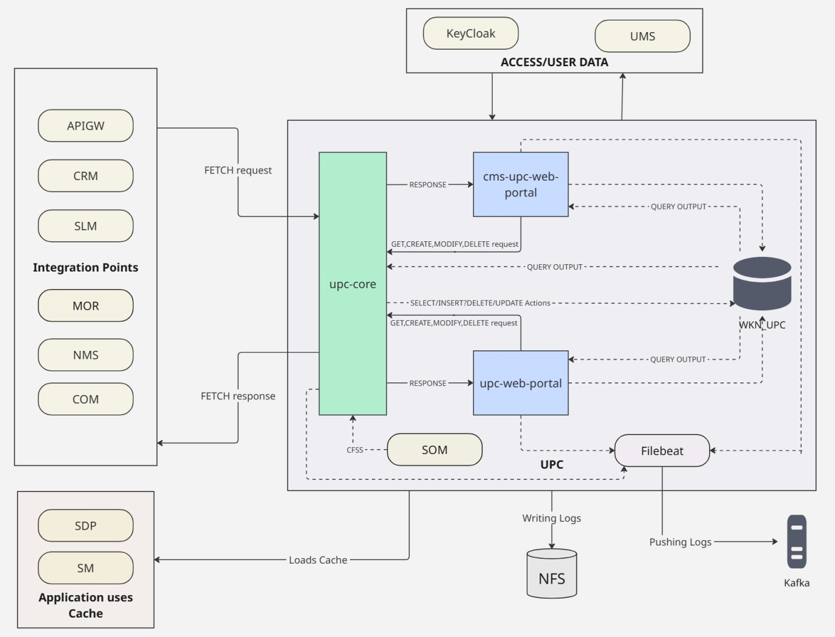
Figure 1.0: High-Level Logical Architecture
This section provides visual representations of the Unified Product Catalogue (UPC) system to help illustrate the High-Level Logical architecture of UPC.

Integration Points
The Unified Product Catalogue (UPC) application integrates with multiple external systems and infrastructure components to provide a seamless, scalable, and secure enterprise-grade solution. Below are the summary of the key integration points and their roles within the UPC ecosystem:
- Keycloak
Provides centralized authentication and token-based access control across the UPC application. All UI interactions are secured using tokens issued by Keycloak, ensuring secure and role-based user access.
- UMS (User Management System)
Acts as the master source for user data. Whenever user-related operations (e.g., user creation, updates, role assignments) occur in UMS, they are synchronized with the UPC system to ensure consistency and accuracy.
- Kafka
Serves as the central log streaming backbone. Filebeat containers push structured logs and CDRs into Kafka topics, which are then consumed by external platforms for monitoring, mediation, reporting, and compliance.

- MySQL InnoDB Cluster via ProxySQL
Acts as the primary data persistence layer for all UPC modules. The use of ProxySQL provides connection pooling and high availability across the five-node InnoDB cluster, supporting both transactional integrity and performance.

- NFS (Network File System)
Used for shared storage of logs, file uploads, and configuration assets. It enables persistent, centralized access to file-based data by various UPC services and downstream systems.

- APIGW (API Gateway)
Third-party systems connect to UPC via the API Gateway to query the bundles, which acts as a secure entry point for the APIs. The upc-core handles request processing from external applications routed through APIGW.

- CRM (Customer Relationship Management)
UPC is integrated with CRM systems, enabling users to view and purchase the bundles since the plans will be having a specific rule set for handling the CRM requests.

- COM (Customer Relationship Management)
UPC is integrated with COM systems, enabling com application to fetch the bundles since the plans will be having a specific eligibility rule for handling the COM requests.

- SLM (Sales Lead Management)
UPC is integrated with SLM systems, enabling agents to view and purchase the bundles since the plans will be having a specific rule set for handling the SLM requests.

- SM (Subscription Management)
UPC is integrated with SM systems, where SM will be storing the BSS plan details in the SM cache to handle the bundle related APIs effectively.

- NMS (Number Management)
UPC is integrated with NMS, enabling agents to fetch the shortcodes since the plans will be having a specific shortcodes to create SDP plans.
- SDP (Service Delivery Platform)
UPC is integrated with SDP systems, where SDP will be storing the VaS plan details in the SDP cache to handle the bundle related APIs effectively.
- MOR (Mo Router)
UPC is integrated with Mo Router systems, where SDP will be storing the VaS plan details in the MOR DB to handle the bundle related APIs effectively (e.g., keyword validations).

Kubernetes Deployment Details
The Unified Product Catalogue (UPC) application is deployed on a Kubernetes cluster using a modular, microservice-based architecture. The application components are logically grouped into three primary pods (upc-core, upc-web-portal and cms-upc-web-portal), each hosting one or more containers including the filebeat based on their functional roles.
Deployments are managed using a GitOps approach via Argo CD, with all resource definitions maintained in version-controlled YAML files. Configurations are structured using Kustomize overlays to enable environment-specific customization.
Each pod is deployed as a Kubernetes Deployment object and is backed by a set of associated resources, including:
- ConfigMaps for application-level configuration files
- Persistent Volumes (NFS-based) for shared storage
- Secrets for managing sensitive information such as credentials
- Filebeat sidecar containers for log and CDR collection
- Horizontal Pod Autoscalers (HPA) for dynamic scaling based on CPU and memory usage

UPC-CORE
The upc-core hosts the core backend services of the UPC application and is a critical component in managing API traffic, third-party integrations, and audit operations.

Overview
Ingress Controller
↓
Service: upc-core (ClusterIP)
├→ Port 8120(upc-core)
↓
Deployment: upc-core-pod
→ upc-core Container
- Image: et02-harbor.safaricomet.net/bss/upc/upc-core:v1.1.0-dev-290
- Port: 8120
- Resources: CPU: 4500m, Memory: 9Gi
- External Mounts:
  - /bss-nfs-doc/UPC
  - /bss-nfs-log/UPC/upc-core

→ filebeat-logs Container
- Image: mdc1-sfcr.safaricomet.net/bss/filebeat:8.1.1
- Resources: CPU: 300m, Memory: 512Mi

→ Monitoring Integration
- upc-core-metrics (port 9011), upc-web-portal-metrics (port 10030), cms-upc-web-portal-metrics (port 10030) all annotated for Prometheus scraping.

Summary

Resources

Microservices | Type | Value | Defined File Name
upc-core | CPU Limit | 4500m | upc-core-resource-patch.yaml
 | CPU Request | 3600m | upc-core-resource-patch.yaml
 | MEM Limit | 9216Mi | upc-core-resource-patch.yaml
 | MEM Request | 5735Mi | upc-core-resource-patch.yaml
filebeat | CPU Limit | 300m | upc-core-resource-patch.yaml
 | CPU Request | 240m | upc-core-resource-patch.yaml
 | MEM Limit | 512Mi | upc-core-resource-patch.yaml
 | MEM Request | 94Mi | upc-core-resource-patch.yaml

Mounts

ConfigMap Name | Mounted In | Mount Path / SubPath | Defined In | External Path | DC2 NFS | MDC1 NFS
upc-core-config | upc-core | /opt/jboss/wildfly/standalone/configuration/standalone.xml | kustomization.yaml, deployment.yaml | upc\upc-core-configs\standalone.xml | NA | NA

Images

Microservice | DC2 Harbor URL | DC2 Tag | MDC1 Harbor URL | MDC1 Tag | Defined in
upc-core | et02-harbor.safaricomet.net/bss/upc/upc-core | v1.1.0-dev-290 | mdc1-sfcr.safaricomet.net/bss/upc-core | v1.1.0-dev-290 | kustomization.yaml
filebeat-logs | et02-harbor.safaricomet.net/bss/filebeat | 8.1.1 | mdc1-sfcr.safaricomet.net/bss/filebeat | 8.1.1 | kustomization.yaml

UPC WEB PORTAL
Upc-web-portal application is responsible for handling configuration, user management, and serving the user interface (UI) for the UPC application for configuring the BSS related use-cases. It plays a key role in administrative functions and front-end interaction.

Overview
Ingress Controller
↓
Service: upc-web-portal (ClusterIP)
├→ Port 8120 (upc-web-portal)
Deployment: upc-web-portal
→ upc-web-portal Container
Image: mdc1-sfcr.safaricomet.net/bss/upc-web-portal:v1.1.3-dev-509
Port: 8120
Resources: CPU: 1000m, Memory: 3500Mi
External Mounts:
/bss-nfs-log/UPC/upc-web-portal

Resources

Microservices | Type | Value | Defined File Name
upc-web-portal | CPU Limit | 1000m | upc-web-portal-resource-patch.yaml
 | CPU Request | 800m | upc-web-portal-resource-patch.yaml
 | MEM Limit | 3500Mi | upc-web-portal-resource-patch.yaml
 | MEM Request | 1800Mi | upc-web-portal-resource-patch.yaml

Mounts

ConfigMap Name | Mounted In | Mount Path / SubPath | Defined In | External Path | DC2 NFS | MDC1 NFS
upc-web-portal-config | upc-web-portal | /opt/jboss/wildfly/standalone/configuration/standalone.xml | kustomization.yaml, deployment.yaml | upc\upc-web-portal-configs\standalone.xml | NA | NA

Images

Microservice | DC2 Harbor URL | DC2 Tag | MDC1 Harbor URL | MDC1 Tag | Defined in
upc-web-portal | et02-harbor.safaricomet.net/bss/upc/upc-web-portal | v1.1.3-dev-509 | mdc1-sfcr.safaricomet.net/bss/upc-web-portal | v1.1.3-dev-509 | kustomization.yaml
filebeat-logs | et02-harbor.safaricomet.net/bss/filebeat | 8.1.1 | mdc1-sfcr.safaricomet.net/bss/filebeat | 8.1.1 | kustomization.yaml

→ filebeat-logs Container
- Image: filebeat-logs:8.1.1
- Resources: CPU: 300m, Memory: 256Mi
- Volumes:
  - upc-web-portal-config (ConfigMap)
    - Mounted at: /etc/filebeat.yml
  - upc-web-portal-log (NFS, read-only)
    - Path: /bss-nfs-log/UPC/upc-web-portal
    - Mounted at: /var/LOGS/
  - tz-config (hostPath)
    - Path: /usr/share/zoneinfo/Africa/Addis_Ababa
    - Mounted at: /etc/localtime
→ Monitoring Integration
- Prometheus Metrics Service: upc-web-portal-metrics
- Port: 10030
- Path: /metrics
- Annotations: Enable scraping via Prometheus for upc-web-portal

CMS-UPC WEB PORTAL
Cms-upc-web-portal is focused on SDP VaS related configuration as well it serves some purpose of CMS application as well.

Overview
Ingress Controller
↓
Service: cms-upc-web-portal
├→ Port 8120 (upc-web-portal)
Deployment: cms-upc-web-portal
→ cms-upc-web-portal Container
Image: et02-harbor.safaricomet.net/bss/cms/cms-upc-web-portal:v1.1.3-dev-509
Port: 8120
Resources: CPU: 1000m, Memory: 2000Mi
External Mounts:
/bss-nfs-log/UPC/upc-web-portal
- Volumes:
  - new-cms-upc-web-portal-config (ConfigMap)
    - Mounted at: /opt/jboss/wildfly/standalone/configuration/standalone.xml
  - tz-config (hostPath)
    - Path: /usr/share/zoneinfo/Africa/Addis_Ababa
    - Mounted at: /etc/localtime

Resources

Microservices | Type | Value | Defined File Name
Cms-upc-web-portal | CPU Limit | 1000m | deployment.yaml
 | CPU Request | 800m | deployment.yaml
 | MEM Limit | 2000Mi | deployment.yaml
 | MEM Request | 800Mi | deployment.yaml

Mounts

ConfigMap Name | Mounted In | Mount Path / SubPath | Defined In | External Path | DC2 NFS | MDC1 NFS
new-cms-upc-web-portal-config | upc-web-portal | /opt/jboss/wildfly/bin/standalone.conf | kustomization.yaml, deployment.yaml | upc\upc-web-portal-configs\standalone.xml | NA | NA

Images

Microservice | DC2 Harbor URL | DC2 Tag | MDC1 Harbor URL | MDC1 Tag | Defined in
upc-web-portal | et02-harbor.safaricomet.net/bss/cms/cms-upc-web-portal | v1.1.3-dev-509 | mdc1-sfcr.safaricomet.net/bss/cms-upc-web-portal l | v1.1.3-dev-509 | kustomization.yaml
filebeat-logs | et02-harbor.safaricomet.net/bss/filebeat | 8.1.1 | mdc1-sfcr.safaricomet.net/bss/filebeat | 8.1.1 | kustomization.yaml

→ filebeat-logs Container
- Image: et02-harbor.safaricomet.net/bss/filebeat:8.1.1
- Resources: CPU: 200m, Memory: 256Mi
- Volumes:
  - new-cms-upc-web-portal-config (ConfigMap)
    - Mounted at: /etc/filebeat.yml
  - tz-config (hostPath)
    - Path: /usr/share/zoneinfo/Africa/Addis_Ababa
    - Mounted at: /etc/localtime
→ Monitoring Integration
- Prometheus Metrics Service: cms-upc-web-portal-metrics
- Port: 10030
- Path: /metrics
- Annotations: Enable scraping via Prometheus for cms-upc-web-portal

Microservices Overview & Configurations
The Unified Product Catalogue (UPC) application relies on a set of key configuration files that govern its runtime behaviour across different environments. These configurations include Datasource definitions, logging settings, system properties, and service-specific parameters. All configuration files are maintained in a centralized Git repository and are organized using environment-specific overlay directories. This structure allows for consistent configuration management across UAT, production, and other environments.
When changes are required, users can clone the Git repository to their local machine, update the relevant configuration files under the appropriate overlay directory, and commit the changes with proper version control. Once changes are pushed to the remote repository, they can be applied to the target environment via Argo CD, which handles synchronization and deployment. This GitOps-based approach ensures that configuration changes are traceable, auditable, and aligned with best practices for continuous delivery.

upc-core

upc-core
The upc-core module serves as the core backend component of the Unified Product Catalogue (UPC) application. It is responsible for handling the primary business logic and processing all incoming requests related to bundle operations. The UI service interacts extensively with this module to perform actions such as creating, viewing, updating, and managing products/prices and its related configurations throughout their lifecycle. As a critical component of the system, the upc-core Services module is tightly integrated with various internal services and external systems.

standalone.cnf

The standalone.cnf file (sometimes also referred to as standalone.conf in WildFly/JBoss deployments) is used to configure JVM-level and environment-specific settings for a JBoss/WildFly application server running in standalone mode.
Path: upc\upc-core-configs\standalone.conf
JAVA_OPTS="-Xms2048m -Xmx8192m -XX:MetaspaceSize=96M -XX:MaxMetaspaceSize=1024m -Djava.net.preferIPv4Stack=true"

Option | Purpose
-Xms2048m | Sets the initial heap size to 2 GB
-Xmx8912m | Sets the maximum heap size to 8 GB
-XX:MetaspaceSize=96M | Initial size for Metaspace (class metadata memory)
-XX:MaxMetaspaceSize=1024m | Maximum size Metaspace can grow to
-Djava.net.preferIPv4Stack | Ensures IPv4 is used if both IPv4 and IPv6 are available

standalone.xml
Defines the JBoss/WildFly server configuration, including the datasource, logging, and subsystem settings.
Path: upc\upc-core-configs\standalone.xml
- Datasource Configuration
<datasource jta="true" jndi-name="java:jboss/datasources/MySqlDS" pool-name="MySqlDS" enabled="true" use-ccm="true" statistics-enabled="true">
<connection-url>jdbc:mysql://upc-proxysql:6033/WKN_UPC?zeroDateTimeBehavior=CONVERT_TO_NULL&amp;autoReconnect=true&amp;useSSL=true&amp;serverTimezone=UTC&amp;enabledTLSProtocols=TLSv1.2&amp;allowLoadLocalInfile=true&amp;characterEncoding=UTF-8&amp;maxReconnects=10</connection-url>
<driver-class>com.mysql.jdbc.Driver</driver-class>
<driver>mysql</driver>
<pool>
<min-pool-size>15</min-pool-size>
<initial-pool-size>15</initial-pool-size>
<max-pool-size>30</max-pool-size>
<allow-multiple-users>false</allow-multiple-users>
</pool>
<security>
- JNDI Name (`java:jboss/datasources/MySqlDS`): Used by apps to access database.
- Connection URL includes parameters like autoReconnect, SSL, timezone, and encoding.
- Min-pool-size and Max-pool-size set limits on DB connections for efficiency.

- Logging Configuration
<periodic-rotating-file-handler name="FILE" autoflush="true">
<formatter>
<named-formatter name="PATTERN"/>
</formatter>
<file relative-to="jboss.server.log.dir" path="server.log"/>
<suffix value=".yyyy-MM-dd"/>
<append value="false"/>
</periodic-rotating-file-handler>
- Enables daily rotation of logs.
- Archives logs with date suffix for easy troubleshooting.
- Stored in WildFly’s log directory.
- Enable different log levels (e.g., INFO, DEBUG, ERROR) based on the environment

- Detailed Logging Handlers & Formatters
<console-handler name="CONSOLE">
<level name="INFO"/>
<formatter>
<named-formatter name="COLOR-PATTERN"/>
</formatter>
</console-handler>
<periodic-rotating-file-handler name="FILE" autoflush="true">
<formatter>
<named-formatter name="PATTERN"/>
</formatter>
<file relative-to="jboss.server.log.dir" path="server.log"/>
<suffix value=".yyyy-MM-dd"/>
<append value="false"/>
</periodic-rotating-file-handler>
<logger category="com.arjuna">
<level name="ERROR"/>
</logger>
<logger category="io.jaegertracing.Configuration">
<level name="ERROR"/>
</logger>
<logger category="org.jboss.as.config">
<level name="ERROR"/>
</logger>
<logger category="sun.rmi">
<level name="ERROR"/>
</logger>
<logger category="com.sixdee.imp">
<level name="INFO"/>
</logger>
<root-logger>
<level name="INFO"/>
<handlers>
<handler name="CONSOLE"/>
<!--handler name="FILE"/-->
</handlers>
</root-logger>
<formatter name="PATTERN">
<pattern-formatter pattern="%d{yyyy-MM-dd HH:mm:ss,SSS} %-5p [%c] (%t) %s%e%n"/>
</formatter>
<formatter name="COLOR-PATTERN">
<pattern-formatter pattern="%K{level}%d{HH:mm:ss,SSS} %-5p [%c] (%t) %s%e%n"/>
</formatter>
- Console-handler outputs log messages to the console with INFO level, useful for real-time debugging.
- Periodic-rotating-file-handler writes logs to files daily, creating archives with a date suffix.
- Specific loggers (like com.arjuna, io.jaegertracing) are set to ERROR to limit detailed logging.
- Root-logger captures general logs at INFO level, sending them to both file and console.
- Custom pattern formatter includes detailed contextual information like timestamp, thread ID, trace IDs, log level, and custom tags.
- Enable different log levels (e.g., INFO, DEBUG, ERROR) based on the environment

- Network & Socket Bindings
<socket-binding-group name="standard-sockets" default-interface="public" port-offset="${jboss.socket.binding.port-offset:40}">
<socket-binding name="ajp" port="${jboss.ajp.port:8009}"/>
<socket-binding name="http" port="${jboss.http.port:8080}"/>
<socket-binding name="https" port="${jboss.https.port:8443}"/>
<socket-binding name="management-http" interface="management" port="${jboss.management.http.port:9990}"/>
<socket-binding name="management-https" interface="management" port="${jboss.management.https.port:9993}"/>
<socket-binding name="txn-recovery-environment" port="4712"/>
<socket-binding name="txn-status-manager" port="4713"/>
<outbound-socket-binding name="mail-smtp">
<remote-destination host="localhost" port="25"/>
</outbound-socket-binding>
</socket-binding-group>

- HTTP port (8080) for regular web traffic.

log4j.xml

The following configuration defines a RollingRandomAccessFile Appender for logging the transactions of UPC application.
Path: upc\upc-core-configs\log4j2.xml
- RollingRandomAccessFile Appender
<RollingRandomAccessFile name="RollingRandomAccessFile" fileName="/var/log/UPC/upc-core/DC1-${myhost}_UPC_BL.log" filePattern="/var/log/UPC/upc-core/DC1-${myhost}_UPC_BL-%d{yyyy-MM-dd-hh}-%i.log" immediateFlush="false" append="true">
<PatternLayout>
<!-- <Pattern>%highlight{%sn %d [%-6p] [%t] %C{1} :[%L] %m%n}</Pattern> -->
<Pattern>[UPC]::[UPC-BL]::[DC1-${myhost}]::[%d]::[%t]::[%sn]::[]::[%p]::[APP]::%m%n</Pattern>
</PatternLayout>
<Policies>
<OnStartupTriggeringPolicy />
<TimeBasedTriggeringPolicy />
<SizeBasedTriggeringPolicy size="100 MB" />
</Policies>
</RollingRandomAccessFile>

Element | Description
RollingRandomAccessFile | Defines a rolling file appender optimized for performance and frequent writes.
append="true" | Ensures logs are appended to the existing file instead of overwriting it.
fileName | Sets the current active log file path. ${env:MY_POD_NAME} dynamically inserts the pod name (used in Kubernetes) to separate logs per pod instance.
filePattern | Defines the naming pattern for archived log files, with timestamp (yyyyMMddHHmmss) and rollover index (%i).
PatternLayout | Specifies the format of each log entry. Here, only the message (%m) followed by a newline (%n) is written—ideal for clean, structured CDR logs.
SizeBasedTriggeringPolicy | Triggers log file rollover every 100MB. modulate="true" aligns rollover to wall-clock time for consistency.
%i | An incremental counter (1, 2, 3…) if multiple files are created in the same hour.
immediateFlush="false" | Controls whether logs are flushed to disk immediately.  false = better performance (logs are buffered).  true = safer (logs appear instantly, but slower).
append="true" | If true, new logs are appended to the file when the app restarts.  If false, the file is overwritten at each startup.
[%d] | Date/time of the log event.
[%t] | Thread name.
[%sn] | Source name.
[%p] | Log level (INFO, DEBUG, ERROR)
%m | Actual log message.
%n | New line.

Filebeat
The filebeat service is used to efficiently manage and forward logs generated by various components of the UPC application. It performs the below functions:
- Log Forwarding to Kafka: Filebeat collects logs from the upc-core application containers—and pushes them to a configured Kafka topic. These logs are then consumed by downstream systems for real-time monitoring, centralized logging, or alert generation.

Log- filebeat.yml

This Filebeat configuration is used to collect logs from multiple UPC microservices and forward them to a centralized Kafka topic (6d-upc-log) for real-time processing, monitoring, and long-term retention.
The setup ensures consistent log formatting and aggregation from various services deployed across different pods and containers.
Path: upc\upc-core-configs\filebeat.yml
filebeat.inputs:
- type: log
tail_files: true
multiline:
pattern: '^\[UPC]'
negate: true
match: after
max_lines: 5000
paths:
- /var/log/UPC/upc-core/DC1-${HOSTNAME}_UPC_BL.log
topics: ["upc_logs"]
kafka.topic:
- 6d-upc-log
document_type: filebeat
fields:
kafka_topic: 6d-upc-log

- type: log: Filebeat is reading plain log files.
- tail_files: true: Begins reading from the end of the file (useful for live pods).
- multiline pattern:

- ^\[UPC]: Log entries start with [UPC], which is used as the anchor line.
- Combines stack traces or error blocks into a single event until the next [UPC]-tagged line is found.
- Prevents partial stack traces from being treated as individual logs.

- paths: Absolute paths to each service’s log file location.
- fields.kafka_topic: Adds a field to dynamically route logs to the correct Kafka topic.

output.kafka:
codec.format:
string: '%{[message]}'
hosts: ["10.4.142.61:9094"]
topic: ‘%{[fields.kafka_topic]}’
partition.round_robin:
reachable_only: false
required_acks: 1
compression: gzip
max_message_bytes: 1000000
sasl.mechanism: SCRAM-SHA-512
security.protocol: SASL_PLAINTEXT
username: 6d
password: GQJZOifOm1LT
topics:
- topic: "6d-upc-log"
has_fields: ['kafka_topic']

- topic: Uses the value of fields.kafka_topic to route logs.
- compression: Reduces size using gzip.
- SCRAM-SHA-512: Ensures secure Kafka authentication.
- max_message_bytes: Ensures large log lines (e.g., stack traces) are supported.

upc-web-portal

upc-web-portal
The upc-web-portal is the user interface (UI) microservice of the Unified Product Catalogue (UPC) application. It provides the front-end interface through which end users interact with the system to create, update, and view tickets.
This service is built to offer a user-friendly experience while abstracting the complexity of the backend logic. It communicates with the backend Business Logic (BL) services, the upc-core to fetch, display, and submit data as requested by the user.
In addition to backend communication, the upc-web-portal integrates with Keycloak for handling authentication and session management. It redirects users to Keycloak for login, validates tokens upon login, and controls access to different features based on user roles and permissions.

standalone.cnf

The standalone.cnf file (sometimes also referred to as standalone.conf in WildFly/JBoss deployments) is used to configure JVM-level and environment-specific settings for a JBoss/WildFly application server running in standalone mode.
Path: upc\upc-web-portal-configs\standalone.conf
JAVA_OPTS="-Xms2048m -Xmx8192m -XX:MetaspaceSize=96M -XX:MaxMetaspaceSize=256m -Djava.net.preferIPv4Stack=true"

Option | Purpose
-Xms2048m | Sets the initial heap size to 2 GB
-Xmx8192m | Sets the maximum heap size to 8 GB
-XX:MetaspaceSize=96M | Initial size for Metaspace (class metadata memory)
-XX:MaxMetaspaceSize=256M | Maximum size Metaspace can grow to
-Djava.net.preferIPv4Stack | Ensures IPv4 is used if both IPv4 and IPv6 are available

standalone.xml
Core configuration file for the WildFly/JBoss server in standalone mode. Controls all subsystems like datasources, logging, security, deployment, EJBs, and more.
Path: upc\upc-web-portal-configs\standalone.xml
- System Properties – Keycloak & URLs
<system-properties>
<property name="jboss.as.management.blocking.timeout" value="6000"/>
<property name="UPC.realm" value="safaricom"/>
<property name="UPC.auth-server-url" value="https://keycloak.bss3.safaricomet.net/auth"/>
<property name="UPC.ssl-required" value="none"/>
<property name="UPC.verify-token-audience" value="true"/>
<property name="UPC.resource" value="Wakanda_UPC"/>
<property name="UPC.credentials.secret" value="3a43128c-095e-4040-91e1-6052ff6811ae"/>
<property name="UPC.use-resource-role-mappings" value="true"/>
<property name="UPC.confidential-port" value="443"/>
<property name="UPC.policy-enforcer" value="{}"/>
<property name="UPC.DISABLE_TRUST_MANAGER" value="true"/>
<property name="UPC.session-listener-server-url" value="http://keycloak-edge-ha:80/auth"/>
<property name="myVariable" value="UPC"/>
</system-properties>
- UPC.auth-server-url: URL of Keycloak server for authentication.
- UPC.resource: Resource (client ID) registered in Keycloak (Wakanda_UPC).
- UPC.credentials.secret: Secret to authenticate this UI with Keycloak.
- UPC.ssl-required: none: SSL is not enforced between app and Keycloak (for internal traffic).
- UPC.policy-enforcer: Enables default policy enforcement.
- myVariable: Used as identifier to know whether the request submitted from UPC [it will be stored in the UPC tables functionalAttribute as UPC].

- Logging Configuration:
<subsystem xmlns="urn:jboss:domain:logging:6.0">
<console-handler name="CONSOLE">
<level name="INFO"/>
<formatter>
<named-formatter name="COLOR-PATTERN"/>
</formatter>
</console-handler>
<periodic-rotating-file-handler name="FILE" autoflush="true">
<formatter>
<named-formatter name="PATTERN"/>
</formatter>
<file path="/var/log/UPC/upc-web-portal/DC1-${jboss.node.name}-server.log"/>
<suffix value=".yyyy-MM-dd-HH"/>
<append value="true"/>
</periodic-rotating-file-handler>
<logger category="com.arjuna">
<level name="WARN"/>
</logger>
<logger category="io.jaegertracing.Configuration">
<level name="WARN"/>
</logger>
<logger category="org.jboss.as.config">
<level name="DEBUG"/>
</logger>
<logger category="sun.rmi">
<level name="WARN"/>
</logger>
<root-logger>
<level name="INFO"/>
<handlers>
<handler name="CONSOLE"/>
<handler name="FILE"/>
</handlers>
</root-logger>
<formatter name="PATTERN">
<pattern-formatter pattern="[UPC]::[UPC_GUI]::[DC1-${jboss.node.name}]::[%d]::[%t]::[%X{traceId}]::[%X{transactionId}]::[%p]::[%X{LOG_TAG}]::[%m]%n"/>
</formatter>
<formatter name="COLOR-PATTERN">
<pattern-formatter pattern="[UPC]::[UPC_GUI]::[DC1-${jboss.node.name}]::[%d]::[%t]::[%X{traceId}]::[%X{transactionId}]::[%p]::[%X{LOG_TAG}]::[%m]%n"/>
</formatter>
</subsystem>
<subsystem xmlns="urn:jboss:domain:batch-jberet:2.0">
<default-job-repository name="in-memory"/>
<default-thread-pool name="batch"/>
<job-repository name="in-memory">
<in-memory/>
</job-repository>
<thread-pool name="batch">
<max-threads count="10"/>
<keepalive-time time="30" unit="seconds"/>
</thread-pool>
</subsystem>
- Console-handler outputs log messages to the console with INFO level, useful for real-time debugging.
- Periodic-rotating-file-handler writes logs to files daily, creating archives with a date suffix.
- Specific loggers (like com.arjuna, io.jaegertracing) are set to ERROR to limit detailed logging.
- Root-logger captures general logs at INFO level, sending them to both file and console.
- Custom pattern formatter includes detailed contextual information like timestamp, thread ID, trace IDs, log level, and custom tags.

- Database Connection
<datasource jta="true" jndi-name="java:jboss/datasources/MySqlDS" pool-name="MySqlDS" enabled="true" use-ccm="true" statistics-enabled="true">
<connection-url>jdbc:mysql://upc-proxysql:6033/WKN_UPC?zeroDateTimeBehavior=CONVERT_TO_NULL&amp;autoReconnect=true&amp;useSSL=true&amp;serverTimezone=UTC&amp;enabledTLSProtocols=TLSv1.2&amp;allowLoadLocalInfile=true&amp;characterEncoding=UTF-8&amp;maxReconnects=10</connection-url>
<driver-class>com.mysql.cj.jdbc.Driver</driver-class>
<driver>mysql</driver>
<pool>
<min-pool-size>10</min-pool-size>
<initial-pool-size>10</initial-pool-size>
<max-pool-size>20</max-pool-size>
<allow-multiple-users>false</allow-multiple-users>
</pool>
<security>
<user-name>upcpod2user</user-name>
<password>bssuser@6Dtech</password>
</security>
<!--<validation>
<valid-connection-checker class-name="org.jboss.jca.adapters.jdbc.extensions.mysql.MySQLValidConnectionChecker"/>
<exception-sorter class-name="org.jboss.jca.adapters.jdbc.extensions.mysql.MySQLExceptionSorter"/>
</validation> -->
<validation>
<background-validation>true</background-validation>
<check-valid-connection-sql>select 1</check-valid-connection-sql>
<validate-on-match>false</validate-on-match>
<background-validation-millis>10000</background-validation-millis>
</validation>
<timeout>
<blocking-timeout-millis>5000</blocking-timeout-millis>
</timeout>
<statement>
<prepared-statement-cache-size>100</prepared-statement-cache-size>
<share-prepared-statements>true</share-prepared-statements>
</statement>
</datasource>
- Connects to the WKN_UPC database via Proxysql.
- Auth: upcpod2user / xxx
- Connection Pool: Min 10 / Max 20 / Prefilled on startup

- Port Configuration
<socket-binding-group name="standard-sockets" default-interface="public" port-offset="${jboss.socket.binding.port-offset:40}">
<socket-binding name="management-http" interface="management" port="${jboss.management.http.port:9990}"/>
<socket-binding name="management-https" interface="management" port="${jboss.management.https.port:9993}"/>
<socket-binding name="ajp" port="${jboss.ajp.port:8009}"/>
<socket-binding name="http" port="${jboss.http.port:8080}"/>
<socket-binding name="https" port="${jboss.https.port:8443}"/>
<socket-binding name="txn-recovery-environment" port="4712"/>
<socket-binding name="txn-status-manager" port="4713"/>
<outbound-socket-binding name="mail-smtp">
<remote-destination host="localhost" port="25"/>
</outbound-socket-binding>
</socket-binding-group>

- HTTP port: 8080

Filebeat
The filebeat service is used to efficiently manage and forward logs generated by various components of the UPC application.
- Log Forwarding to Kafka: Filebeat collects logs from upc-core application containers—and pushes them to a configured Kafka topic. These logs are then consumed by downstream systems for real-time monitoring, centralized logging, or alert generation.

Log - filebeat.yml

This Filebeat configuration is used to collect logs from multiple UPC microservices and forward them to a centralized Kafka topic (6d-upc-log) for real-time processing, monitoring, and long-term retention.
The setup ensures consistent log formatting and aggregation from various services deployed across different pods and containers.
Path: upc\upc-web-portal-configs\filebeat.yml
filebeat.inputs:
- type: log
tail_files: true
multiline:
pattern: '^\[UPC]'
negate: true
match: after
max_lines: 5000
paths:
- /var/log/UPC/upc-web-portal/DC1-${HOSTNAME}-server.log
topics: ["upc_logs"]
kafka.topic:
- 6d-upc-log
document_type: filebeat
fields:
kafka_topic: 6d-upc-log

- type: log: Filebeat is reading plain log files.
- tail_files: true: Begins reading from the end of the file (useful for live pods).
- multiline pattern:

- ^\[UPC]: Log entries start with [UPC], which is used as the anchor line.
- Combines stack traces or error blocks into a single event until the next [UPC]-tagged line is found.
- Prevents partial stack traces from being treated as individual logs.

- paths: Absolute paths to each service’s log file location.
- fields.kafka_topic: Adds a field to dynamically route logs to the correct Kafka topic.

output.kafka:
codec.format:
string: '%{[message]}'
hosts: ["10.4.142.61:9094"]
topic: ‘%{[fields.kafka_topic]}’
partition.round_robin:
reachable_only: false
required_acks: 1
compression: gzip
max_message_bytes: 1000000
sasl.mechanism: SCRAM-SHA-512
security.protocol: SASL_PLAINTEXT
username: 6d
password: GQJZOifOm1LT
topics:
- topic: "6d-upc-log"
has_fields: ['kafka_topic']

- topic: Uses the value of fields.kafka_topic to route logs.
- compression: Reduces size using gzip.
- SCRAM-SHA-512: Ensures secure Kafka authentication.
- max_message_bytes: Ensures large log lines (e.g., stack traces) are supported.

cms-upc-web-portal

cms-upc-web-portal
The cms-upc-web-portal is the user interface (UI) microservice of the Unified Product Catalogue (UPC) application which serves the functionality of creating the SDP products and its related configurations [alongside CMS also uses the same UI for the CMS related configurations]. It provides the front-end interface through which end users interact with the system to create, update, and view tickets.
This service is built to offer a user-friendly experience while abstracting the complexity of the backend logic. It communicates with the backend Business Logic (BL) services, the upc-core to fetch, display, and submit data as requested by the user.
In addition to backend communication, the upc-web-portal integrates with Keycloak for handling authentication and session management. It redirects users to Keycloak for login, validates tokens upon login, and controls access to different features based on user roles and permissions.

standalone.conf

The standalone.conf file (sometimes also referred to as standalone.cnf in WildFly/JBoss deployments) is used to configure JVM-level and environment-specific settings for a JBoss/WildFly application server running in standalone mode.
Path: cms\cms-upc-web-portal-configs\standalone.conf
JAVA_OPTS="-Xms64m -Xmx512m -XX:MetaspaceSize=96M -XX:MaxMetaspaceSize=256m -Djava.net.preferIPv4Stack=true"

Option | Purpose
-Xms64m | Sets the initial heap size to 64MB
-Xmx512m | Sets the maximum heap size to 512MB
-XX:MetaspaceSize=96M | Initial size for Metaspace (class metadata memory)
-XX:MaxMetaspaceSize=256M | Maximum size Metaspace can grow to
-Djava.net.preferIPv4Stack | Ensures IPv4 is used if both IPv4 and IPv6 are available

standalone.xml
Core configuration file for the WildFly/JBoss server in standalone mode. Controls all subsystems like datasources, logging, security, deployment, EJBs, and more.
Path: upc\upc-web-portal-configs\standalone.xml
- System Properties – Keycloak & URLs
<system-properties>
<property name="jboss.as.management.blocking.timeout" value="6000"/>
<property name="UPC.realm" value="safaricom"/>
<property name="UPC.auth-server-url" value="https://keycloak.bss3.safaricomet.net/auth"/>
<property name="UPC.session-listener-server-url" value="https://keycloak.bss3.safaricomet.net/auth"/>
<property name="UPC.ssl-required" value="none"/>
<property name="UPC.verify-token-audience" value="true"/>
<property name="UPC.resource" value="Wakanda_CMS"/>
<property name="UPC.credentials.secret" value="lW2ktSGuzvg0SnKEWMlz7O8RSnd1H2aw"/>
<property name="UPC.use-resource-role-mappings" value="true"/>
<property name="UPC.confidential-port" value="443"/>
<property name="UPC.policy-enforcer" value="{}"/>
<property name="UPC.DISABLE_TRUST_MANAGER" value="true"/>
<property name="myVariable" value="SDP"/>
</system-properti
- UPC.auth-server-url: URL of Keycloak server for authentication.
- UPC.resource: Resource (client ID) registered in Keycloak (Wakanda_CMS).
- UPC.credentials.secret: Secret to authenticate this UI with Keycloak.
- UPC.ssl-required: none: SSL is not enforced between app and Keycloak (for internal traffic).
- UPC.policy-enforcer: Enables default policy enforcement.
- myVariable: Used as identifier to know whether the request submitted from UPC [it will be stored in the UPC tables functionalAttribute as SDP].

- Logging Configuration:
<subsystem xmlns="urn:jboss:domain:logging:6.0">
<console-handler name="CONSOLE">
<level name="INFO"/>
<formatter>
<named-formatter name="COLOR-PATTERN"/>
</formatter>
</console-handler>
<periodic-rotating-file-handler name="FILE" autoflush="true">
<formatter>
<named-formatter name="COLOR-PATTERN"/>
</formatter>
<file path="/var/log/UPC/upc-web-portal/${jboss.node.name}-server.log"/>
<suffix value=".yyyy-MM-dd-HH"/>
<append value="true"/>
</periodic-rotating-file-handler>
<logger category="com.arjuna">
<level name="WARN"/>
</logger>
<logger category="io.jaegertracing.Configuration">
<level name="WARN"/>
</logger>
<logger category="org.jboss.as.config">
<level name="DEBUG"/>
</logger>
<logger category="sun.rmi">
<level name="WARN"/>
</logger>
<root-logger>
<level name="INFO"/>
<handlers>
<handler name="CONSOLE"/>
<handler name="FILE"/>
</handlers>
</root-logger>
<formatter name="PATTERN">
<pattern-formatter pattern="[UPC]::[UPC-GUI]::[${jboss.node.name}]::[%d]::[%t]::[%X{INFOId}]::[%X{transactionId}]::[%p]::[%X{LOG_TAG}]::[%m]%n"/>
</formatter>
<formatter name="COLOR-PATTERN">
<pattern-formatter pattern="[UPC]::[UPC-GUI]::[${jboss.node.name}]::[%d]::[%t]::[%X{INFOId}]::[%X{transactionId}]::[%p]::[%X{LOG_TAG}]::[%m]%n"/>
</formatter>
</subsystem>
<subsystem xmlns="urn:jboss:domain:batch-jberet:2.0">
<default-job-repository name="in-memory"/>
<default-thread-pool name="batch"/>
<job-repository name="in-memory">
<in-memory/>
</job-repository>
<thread-pool name="batch">
<max-threads count="10"/>
<keepalive-time time="30" unit="seconds"/>
</thread-pool>
</subsystem>

- Console-handler outputs log messages to the console with INFO level, useful for real-time debugging.
- Periodic-rotating-file-handler writes logs to files daily, creating archives with a date suffix.
- Specific loggers (like com.arjuna, io.jaegertracing) are set to ERROR to limit detailed logging.
- Root-logger captures general logs at INFO level, sending them to both file and console.
- Custom pattern formatter includes detailed contextual information like timestamp, thread ID, trace IDs, log level, and custom tags.

- Database Connection
<datasource jta="true" jndi-name="java:jboss/datasources/MySqlDS" pool-name="MySqlDS" enabled="true" use-ccm="true" statistics-enabled="true">
<connection-url>jdbc:mysql://cms-proxysql:6033/WKN_UPC?zeroDateTimeBehavior=CONVERT_TO_NULL&amp;autoReconnect=true&amp;useSSL=true&amp;serverTimezone=EAT&amp;enabledTLSProtocols=TLSv1.2&amp;allowLoadLocalInfile=true&amp;characterEncoding=UTF-8</connection-url>
<driver>mysql</driver>
<pool>
<min-pool-size>5</min-pool-size>
<initial-pool-size>5</initial-pool-size>
<max-pool-size>20</max-pool-size>
<allow-multiple-users>false</allow-multiple-users>
</pool>
<security>
<user-name>cmsupcuipoduser</user-name>
<password>bssuser@6Dtech</password>
</security>
<timeout>
<set-tx-query-timeout>true</set-tx-query-timeout>
<blocking-timeout-millis>0</blocking-timeout-millis>
<idle-timeout-minutes>0</idle-timeout-minutes>
<query-timeout>100</query-timeout>
<use-try-lock>0</use-try-lock>
<allocation-retry>0</allocation-retry>
<allocation-retry-wait-millis>0</allocation-retry-wait-millis>
</timeout>
<statement>
<prepared-statement-cache-size>100</prepared-statement-cache-size>
<share-prepared-statements>true</share-prepared-statements>
</statement>
<validation>
<check-valid-connection-sql>select 1</check-valid-connection-sql>
<validate-on-match>false</validate-on-match>
<background-validation-millis>10000</background-validation-millis>
</validation>
</datasource>
<datasource jta="true" jndi-name="java:jboss/datasources/MySqlDS1" pool-name="MySqlDS1" enabled="true" use-ccm="true" statistics-enabled="true">
<connection-url>jdbc:mysql://10.4.74.157:3306/WKN_RPT?zeroDateTimeBehavior=CONVERT_TO_NULL&amp;autoReconnect=true&amp;useSSL=false&amp;nullNamePatternMatchesAll=true&amp;useUnicode=yes&amp;characterEncoding=UTF-8</connection-url>
<driver>mysql</driver>
<pool>
<min-pool-size>1</min-pool-size>
<initial-pool-size>2</initial-pool-size>
<max-pool-size>3</max-pool-size>
<allow-multiple-users>false</allow-multiple-users>
</pool>
<security>
<user-name>rptuser</user-name>
<password>bssuser@6Dtech</password>
</security>
<validation>
<check-valid-connection-sql>select 1</check-valid-connection-sql>
</validation>
</datasource>
- Connects to the WKN_UPC and WKN_RPT database via Proxysql.
- Auth: upcpod2user and rptuser / xxx
- Connection Pool: Min 5 / Max 20 / & Min 1 / Max 3 /Prefilled on startup

- Port Configuration
<socket-binding-group name="standard-sockets" default-interface="public" port-offset="${jboss.socket.binding.port-offset:40}">
<socket-binding name="management-http" interface="management" port="${jboss.management.http.port:9990}"/>
<socket-binding name="management-https" interface="management" port="${jboss.management.https.port:9993}"/>
<socket-binding name="ajp" port="${jboss.ajp.port:8009}"/>
<socket-binding name="http" port="${jboss.http.port:8080}"/>
<socket-binding name="https" port="${jboss.https.port:8443}"/>
<socket-binding name="txn-recovery-environment" port="4712"/>
<socket-binding name="txn-status-manager" port="4713"/>
<outbound-socket-binding name="mail-smtp">
<remote-destination host="localhost" port="25"/>
</outbound-socket-binding>
</socket-binding-group>

- HTTP port: 8080

Filebeat
The filebeat service is used to efficiently manage and forward logs generated by various components of the UPC application.
- Log Forwarding to Kafka: Filebeat collects logs from cms-upc-web-portal application containers—and pushes them to a configured Kafka topic. These logs are then consumed by downstream systems for real-time monitoring, centralized logging, or alert generation.

Log - filebeat.yml

This Filebeat configuration is used to collect logs from multiple UPC microservices and forward them to a centralized Kafka topic (6d-cms-logs) for real-time processing, monitoring, and long-term retention.
The setup ensures consistent log formatting and aggregation from various services deployed across different pods and containers.
Path: cms\cms-upc-web-portal-configs\filebeat.yml
filebeat.inputs:
- type: log
tail_files: true
multiline:
type: pattern
pattern: '^\[UPC]'
negate: true
match: after
max_lines: 5000
paths:
- /opt/jboss/wildfly/standalone/log/server.log
topics: ["6d-cms-logs"]
kafka.topic:
- 6d-cms-logs
document_type: filebeat
fields:
kafka_topic: 6d-cms-logs

- type: log: Filebeat is reading plain log files.
- tail_files: true: Begins reading from the end of the file (useful for live pods).
- multiline pattern:

- ^\[UPC]: Log entries start with [UPC], which is used as the anchor line.
- Combines stack traces or error blocks into a single event until the next [UPC]-tagged line is found.
- Prevents partial stack traces from being treated as individual logs.

- paths: Absolute paths to each service’s log file location.
- fields.kafka_topic: Adds a field to dynamically route logs to the correct Kafka topic.

output.kafka:
codec.format:
string: '%{[message]}'
hosts: ["10.4.142.61:9094"]
topic: ‘%{[fields.kafka_topic]}’

partition.hash.kafka_topic:
reachable_only: false
required_acks: 1
compression: gzip
max_message_bytes: 1000000
sasl.mechanism: SCRAM-SHA-512
security.protocol: SASL_PLAINTEXT
username: 6d
password: oGX41IFWoLdG
topics:
- topic: "6d-cms-logs"
has_fields: ['kafka_topic']
- topic: Uses the value of fields.kafka_topic to route logs.
- compression: Reduces size using gzip.
- SCRAM-SHA-512: Ensures secure Kafka authentication.
- max_message_bytes: Ensures large log lines (e.g., stack traces) are supported.

Keycloak Integration
The Unified Product Catalogue (UPC) application uses Keycloak as its identity provider to implement Single Sign-On (SSO) and fine-grained access control. Authentication, role resolution, and UI access permissions are managed through a combination of client settings, access tokens, and role scopes issued by Keycloak.

SSO Authentication Flow
The UPC application is registered as a confidential client in Keycloak under the name Wakanda_UPC (Wakanda_CMS for cms-upc-web-portal). The following describes the authentication flow:
- SSO Login Page
Users are presented with a common login screen listing all available clients.

- Client Redirect to Base URL
When users click the UPC client (Wakanda_UPC), they are redirected to the Base URL defined in the client configuration:
https://upcui.bss2.safaricomet.net/GUI/index.jsp

https://upcui.bss3.safaricomet.net/GUI/index.jsp

Ingress details [upc.bss2.safaricomet.net] - 10.3.141.19
Ingress details [upc-core.bss3.safaricomet.net] - 10.4.42.19
Egress IP DC2 - 10.3.142.5
Egress IP MDC1 - 10.4.44.3

Note: Egress IP is not something provided specifically for UPC.

- Keycloak Redirection
UPC forwards the user to Keycloak for authentication using the OpenID Connect (OIDC) protocol.

- Code Grant and Token Generation
After successful login, Keycloak returns a code to the UPC application via the Valid Redirect URI. UPC then uses this code to request an access token.

- User Role Fetch and UI Rendering
Using this access token, UPC queries Keycloak for user permissions (scopes). Based on the roles/scopes returned, UPC conditionally displays the appropriate screens and features.

Keycloak Client Configuration Highlights

Field | Value
Client ID | Wakanda_UPC
Protocol | openid-connect
Access Type | confidential
Standard Flow | Enabled
Direct Access Grants | Enabled
Base URL | https://upcui.bss2.safaricomet.net/GUI/index.jsp
Valid Redirect URIs | https://upcui.bss2.safaricomet.net/*, https://upcui.bss3.safaricomet.net/*
Login Theme | safaricom_et_bss_int-sebi-keycloak-theme

Roles and Scopes Management
Keycloak roles are used to control access to specific parts of the UPC UI. Roles are mapped to scopes and permissions within the client.
- Roles represent job functions or operational responsibilities (e.g., Admin_Role).
- Scopes define the type of access (e.g., view, edit, create, delete) that a role has on a given resource.
- These mappings determine:
- Which screens are visible to the user
- Which buttons (like “Create”, “Delete”, “Modify”) are enabled
To better understand user roles and their corresponding permissions, please refer to the attached role matrix document: (draft)

Note: The role matrix must now be maintained by the L2 team, and updated whenever a new menu is added, a new role is introduced, or an existing role is modified in UPC. Maintaining this matrix ensures that permissions stay aligned with business requirements and security policies.

Note: The Scope Mapping matrix must now be maintained by the L2 team, and updated whenever a new menu is added, a new role is introduced, or an existing role is modified in UPC. Maintaining this matrix ensures that permissions stay aligned with business requirements and security policies.

Fine-Grained Access Control Configuration
Keycloak allows fine-grained access control by combining resources, scopes, permissions, and policies. This enables UPC to securely control access to specific features, buttons, or API endpoints based on the user's role.

Key Concepts

Component | Description
Resource | Represents a protected entity (e.g., a screen or button in UPC)
Scope | Defines the type of access permitted on a resource (e.g., view, create, edit)
Policy | Defines rules to evaluate if access should be granted (typically role-based)
Permission | Connects resource + scope + policy (it's the access rule engine)

Step-by-Step: Configuring Fine-Grained Access
- Define a Resource

- Navigate to Clients → Wakanda_UPC → Authorization → Resources.
- Click “Create”.
- Fill in:
- Name: UPC_VIEW_PLAN
- Display Name: Plan View Access
- URI (optional): Not required
- Type: Not required
- Save the resource.
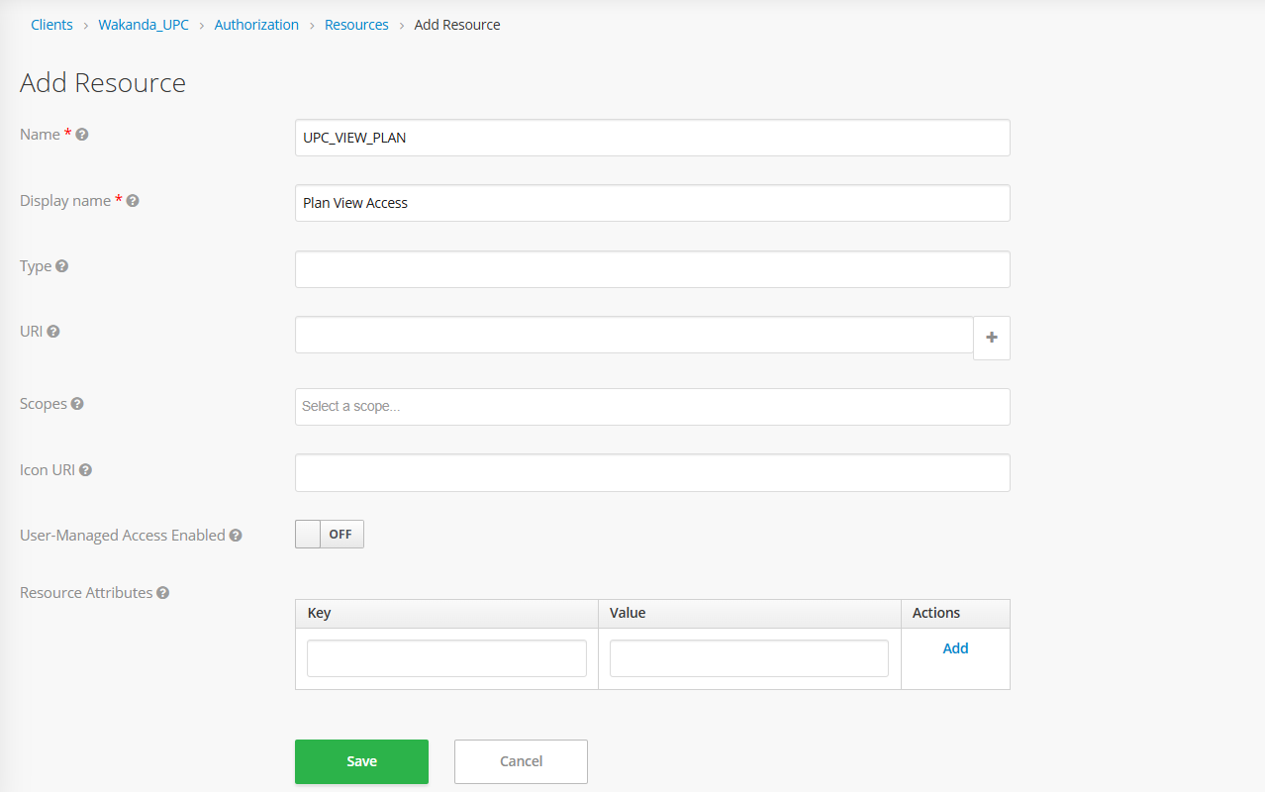
- Define Scopes

- Go to Clients → Wakanda_UPC → Authorization → Scopes.
- Click “Create”.
- Add scopes like:
- view
- create
- edit
- delete
- Save each scope.
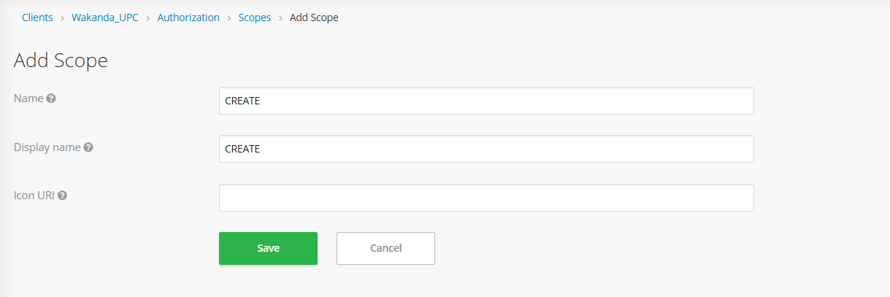
- Create a Role-Based Policy
- Go to Clients → Wakanda_UPC → Authorization → Policies.
- Click “Create” → Type: Role-based.
- Fill in:
  - Name: UPC_VIEW_PLAN_POLICY
  - Logic: Positive
  - Apply to Role(s): UPC_VIEW_PLAN (or relevant role)
  - Realm Roles: Not required
  - Clients: Wakanda_UPC
  - Client Roles: Select all the roles which need access to this policy
- Save the policy.
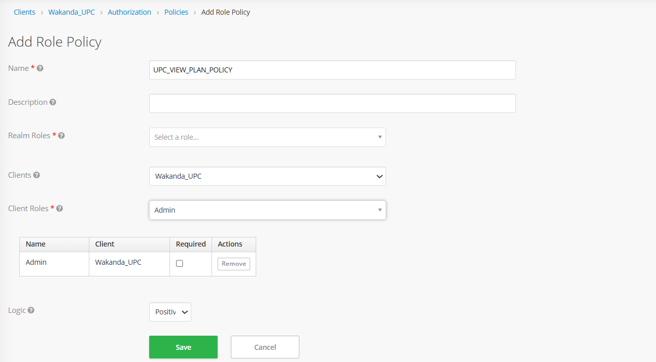
4. Create a Permission
- Navigate to Clients → Wakanda_UPC → Authorization → Permissions.
- Click “Create” → Type: Scope-Based.
- Fill in:
- Name: UPC_VIEW_PLAN_PERMISSION
- Resource: UPC_VIEW_PLAN (optional)
- Scopes: create
- Policies: UPC_VIEW_POLICY
- Save the permission.
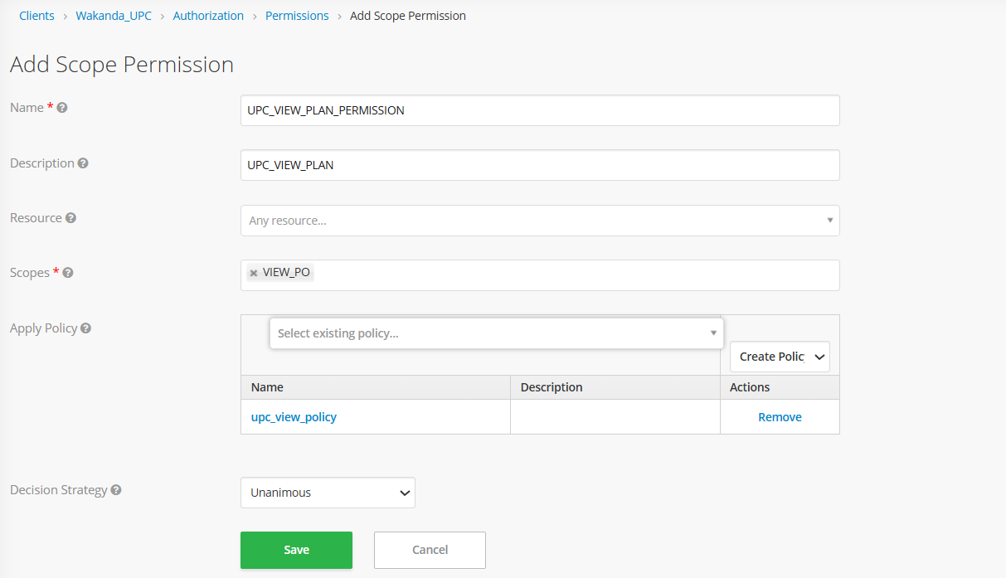

Mapping Reference Sheet
For a full mapping of UI menus to:
- Resources
- Associated Scopes
- Required Permissions
- Purpose of the scopes
Attached Reference:

Important: This file must now be owned and maintained by the L2 team. Any time a new screen, feature, resource, or scope is introduced in UPC. It must be added to this mapping file. All changes should be tracked and reviewed regularly in this sheet and as well as in the role matrix

Database & Persistence

Database Overview
The Unified Product Catalogue (UPC) application utilizes a MySQL InnoDB Cluster deployed across five virtual machines to ensure high availability and data consistency. A dedicated ProxySQL pod is used to provide connection pooling and to route database traffic from the application to the appropriate MySQL nodes. All microservices connect to the database through this ProxySQL layer using JNDI-configured datasources DB Engine: MySQL 8.x
- Connection Proxy: ProxySQL (port 6033)
- Primary Database Name: WKN_UPC

Table Definitions
The below file contains details of all UPC application-related both Data and Configuration tables, including their purpose, key column descriptions, and mappings to other related tables, if any

DB Server Details
Server Name | Server IP | DC | Cluster
mdc1-bss-adb04 | 10.4.74.135 | MDC1 | Cluster 2
mdc1-bss-adb05 | 10.4.74.136 | MDC1
mdc1-bss-adb06 | 10.4.74.137 | MDC1
et02-bss-adb04 | 10.3.174.27 | DC2
et02-bss-adb05 | 10.3.174.28 | DC2

DB User Credentials
Username | Password | Type of User | Database
upcpod1user | xxxxx | Application User | WKN_UPC
upcpod2user | xxxxx | Application User | WKN_UPC
upcpod3user | xxxxx | Application User | WKN_UPC
upcadmin | xxxxx | DB Admin User | WKN_UPC

Important: The application-specific database user must not be used for any manual connections under normal circumstances. Manual access using this user is permitted only for initial connectivity testing during setup or troubleshooting.

The admin user has privileges for read, write, and delete operations on the database. Any write or delete action performed using the admin user will be captured in the audit logs.
Manual write or delete operations on the database are strictly discouraged in all environments, as they may compromise data integrity and bypass application-level validations.

Safe Execution of Read-Only Queries
To ensure optimal performance and data consistency, all resource-intensive SELECT queries must follow the guidelines below when executed against the database.
Execution Policy:
- All heavy or exploratory read queries must be executed only on secondary database servers.
- Primary database servers must not be used for such queries to avoid impacting real-time application traffic and write performance.
Purpose of Secondary Server Validation:
Before executing a query, it is essential to:
- Identify secondary servers that are currently in sync with the primary.
- Verify there is no replication lag which may result in stale or inconsistent data.
A secondary server with a non-zero queue may be lagging the primary and therefore may not reflect the most recent data.

Validation Criteria for Secondary Server Selection:
The following conditions must be satisfied before running queries:
Metric | Expected Value
QUEUE (COUNT_TRANSACTIONS_IN_QUEUE) | 0
COUNT_TRANSACTIONS_REMOTE_IN_APPLIER_QUEUE | 0

These metrics confirm that the secondary server is idle and fully synchronized with the primary.
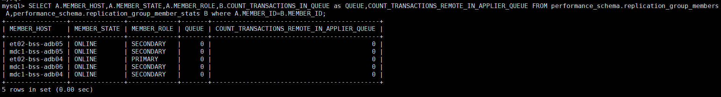
SQL Query to Identify Eligible Secondary Servers:
SELECT A.MEMBER_HOST,A.MEMBER_STATE,A.MEMBER_ROLE,B.COUNT_TRANSACTIONS_IN_QUEUE as QUEUE,COUNT_TRANSACTIONS_REMOTE_IN_APPLIER_QUEUE FROM performance_schema.replication_group_members A ,performance_schema.replication_group_member_stats B where A.MEMBER_ID=B.MEMBER_ID;

Explanation of Fields:
- MEMBER_HOST: Hostname of the MySQL server.
- MEMBER_STATE: Current state of the node (e.g., ONLINE).
- MEMBER_ROLE: Role within the replication group (PRIMARY or SECONDARY).
- QUEUE: Number of local transactions pending on the node.
- COUNT_TRANSACTIONS_REMOTE_IN_APPLIER_QUEUE: Number of remote transactions yet to be applied from the group.
Execute the read query only if a secondary node is ONLINE and both queue values are zero.

If No Suitable Server Is Available:
- Do not proceed with the query.
- Wait until a secondary node becomes available that meets the above conditions.
- Optionally, implement a polling mechanism or monitoring alert to detect when an idle secondary is ready.

Benefits of Following This Approach:
- Prevents unnecessary load on the primary server, maintaining performance for critical transactions.
- Ensures accurate and up-to-date results by avoiding stale reads.
- Supports reliable backend analytics, reporting, and audit processes.

DB Backup & Archiving
To ensure data integrity, disaster recovery readiness, and the ability to recover from accidental configuration changes, a comprehensive backup strategy is implemented for the UPC database (WKN_UPC) as part of the Cluster 2 MySQL deployment.

MySQL Enterprise Backup (MEB) – Cluster-Level Snapshot
A scheduled MySQL Enterprise Backup (MEB) process is configured to take daily backups of the entire Cluster 2, which includes the UPC database. The backup strategy follows a hybrid approach:
- Full Back up: Performed twice a week (typically on fixed days → Monday and Thursday).
- Incremental Backup: Performed on the remaining days.
This ensures storage efficiency while maintaining reliable recovery points.
Backup Scheduling & Execution
- The MEB is triggered via a scheduled shell script at 04:00 AM daily on all five database nodes.
- Only one node will execute the actual backup at any given time, based on internal eligibility logic.
- The same node will continue to perform backups until it becomes unavailable, in which case another node takes over.
Cron Schedule:
00 04 * * * sh -x /data/Daily_MEB_Job/run_meb.sh >> /data/Daily_MEB_Job/logs/meb_log.log 2>&1

Note: This script is scheduled under the root user on all Cluster 2 database servers to enable automated MySQL Enterprise Backup (MEB) execution. Only one eligible node will perform the backup at a time, based on internal logic.

Backup Path Locations:
Hostname | Server IP | Path
mdc1-bss-adb04 | 10.4.74.135 | /db-backup/MEB_CLUSTER
mdc1-bss-adb05 | 10.4.74.136 | /db-backup/MEB_CLUSTER
mdc1-bss-adb06 | 10.4.74.137 | /db-backup/MEB_CLUSTER
et02-bss-adb04 | 10.3.174.27 | /db-backup/MEB_CLUSTER
et02-bss-adb05 | 10.3.174.28 | /db-backup/MEB_CLUSTER

Important: Since this MEB script takes a snapshot of the entire cluster, no modifications should be made to the backup script without prior consultation with the Onshore 6D L2 Team.

Table Dump before any Configuration – Fine-Grained Recovery
As the MEB snapshot covers the entire cluster, restoring a specific table or row from it is not practical for minor data recovery needs. To address this, we can take a dump using the below command.
This allows L2 support to restore configuration data in case of accidental changes without impacting the broader system.
mysqldump -u***** -p***** -h10.3.174.27 -P3306 WKN_UPC --single-transaction --quick --lock-tables=false --set-gtid-purged=OFF --ignore-table=WKN_UPC.SM_SUBSCRIPTION_00 --ignore-table=WKN_UPC.SM_SUBSCRIPTION_01 --ignore-table=WKN_UPC.SM_SUBSCRIPTION_02 --ignore-table=WKN_UPC.SM_SUBSCRIPTION_03 --ignore-table=WKN_UPC.SM_SUBSCRIPTION_04 --ignore-table=WKN_UPC.SM_SUBSCRIPTION_05 --ignore-table=WKN_UPC.SM_SUBSCRIPTION_06 --ignore-table=WKN_UPC.SM_SUBSCRIPTION_07 --ignore-table=WKN_UPC.SM_SUBSCRIPTION_08 --ignore-table=WKN_UPC.SM_SUBSCRIPTION_09 --ignore-table=WKN_UPC.SM_PROFILE_00 --ignore-table=WKN_UPC.SM_PROFILE_01 --ignore-table=WKN_UPC.SM_PROFILE_02 --ignore-table=WKN_UPC.SM_PROFILE_03 --ignore-table=WKN_UPC.SM_PROFILE_04 --ignore-table=WKN_UPC.SM_PROFILE_05 --ignore-table=WKN_UPC.SM_PROFILE_06 --ignore-table=WKN_UPC.SM_PROFILE_07 --ignore-table=WKN_UPC.SM_PROFILE_08 --ignore-table=WKN_UPC.SM_PROFILE_09 > UPC_DB_DUMP_FOR_ACTIVITY_<DATE>.sql

Use the below command to put the dump back to the database if there is unforeseen issue occurs,
mysql -u***** -p***** -h10.3.174.27 -P3306 WKN_UPC < UPC_DB_DUMP_FOR_ACTIVITY_17_03_2025.sql

CI/CD & Deployment

This section outlines the CI/CD workflow for the UPC application deployed on Kubernetes in the MDC1 and DC2 production environments. The deployment approach focuses on GitOps principles, with centralized configuration management, controlled image delivery, and manual syncing through ArgoCD.

Overview

Component | Role
Git Repository | Stores production deployment and application configurations (kustomization.yaml, deployment.yaml, etc.)
Git Extension | Used by engineers to commit and push changes to the Git repository
Harbor Registry | Hosts Docker images for all UPC microservices
ArgoCD | Monitors Git repository and syncs changes to target Kubernetes clusters
Environment Scope | GitOps applies to Production only (MDC1 & EDC2)

Deployment Workflow Overview
The UPC production deployment process involves collaboration between the L3 Dev and L2 Operations teams. Configuration is managed through Git, and synchronization is performed via ArgoCD. In the event of ArgoCD issues, manual deployment via the jump server is also supported.

Git Extension Setup on Local Machine (L2)
To prepare for configuration editing, L2 engineers must install Git Extension locally and use VS Code for updating files.
Installation & Setup:
- Install Git Extension and clone the production Repository
Refer the attached document for installing portable git extension in your local machine.
- Edit in VS Code
- Open the folder in Visual Studio Code.
- Navigate to the relevant path (e.g., overlays/mdc1/upc/)
- Edit and save the changes

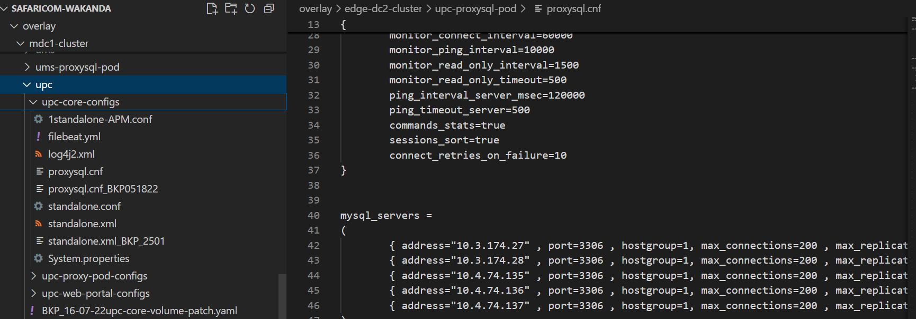

- Commit and Push Changes
Use Git Extension to:
- Pull & Merge all the changes before pushing any new changes to avoid conflicts.

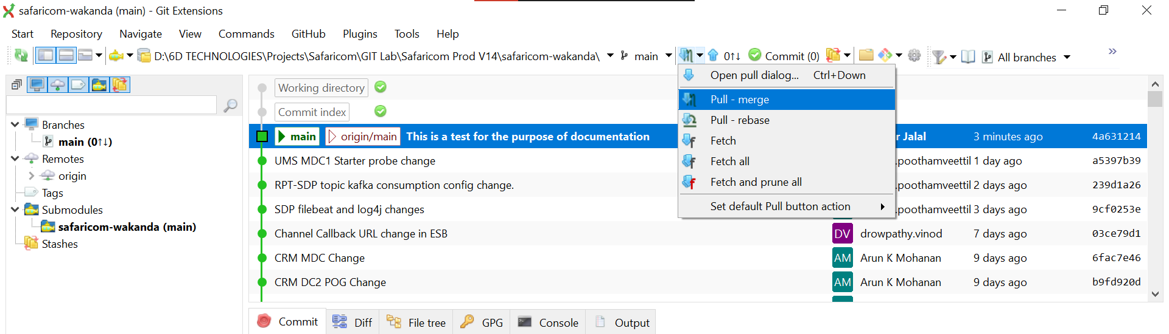

- Stage changes
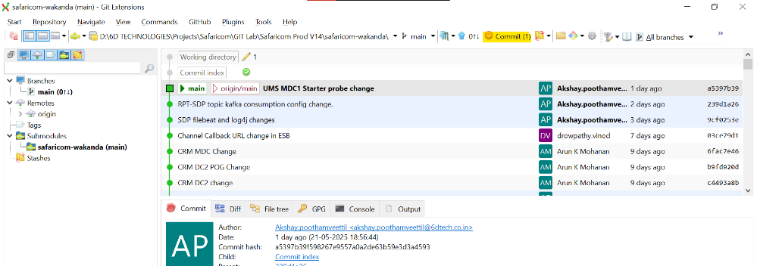
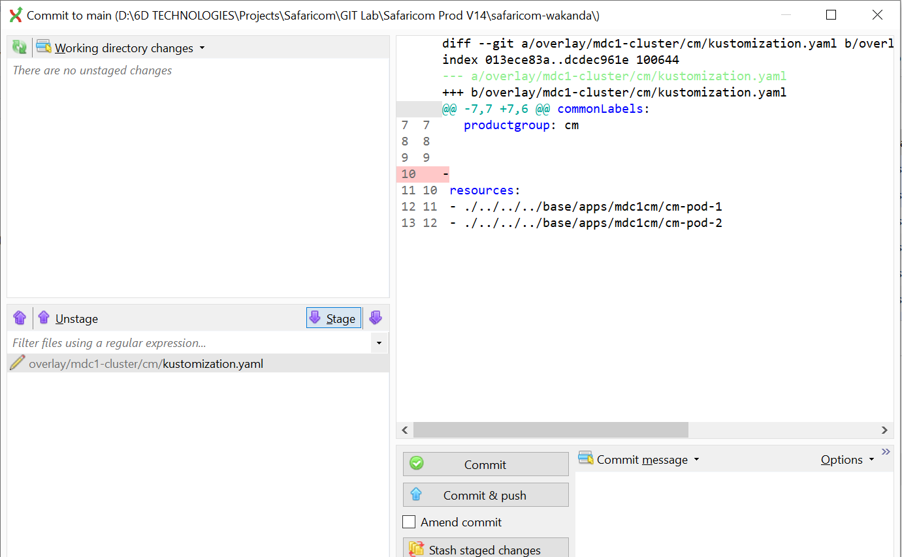
- Commit & push with a clear message
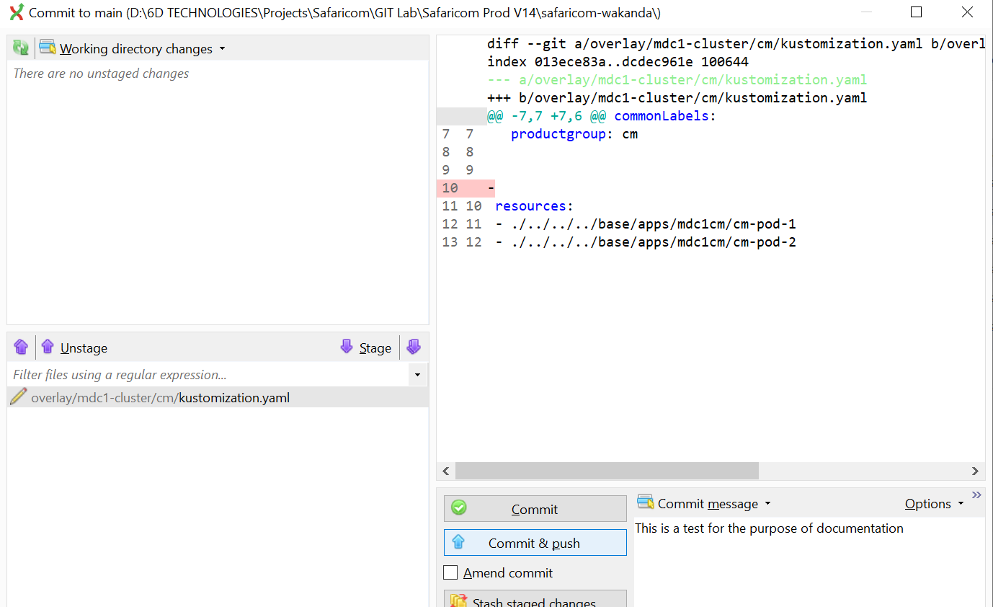
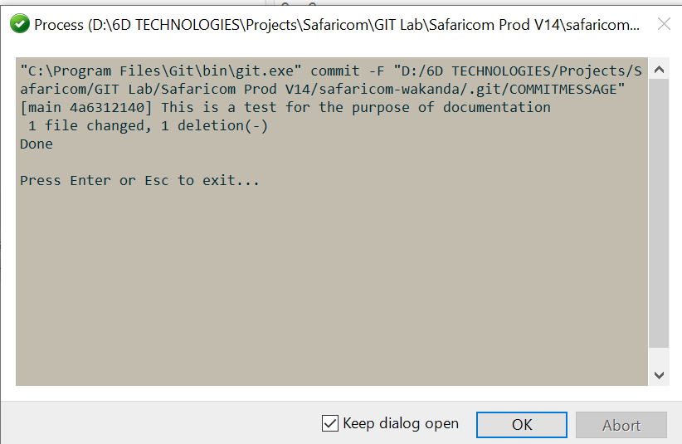
- After commit and push the changes can be viewed as below:
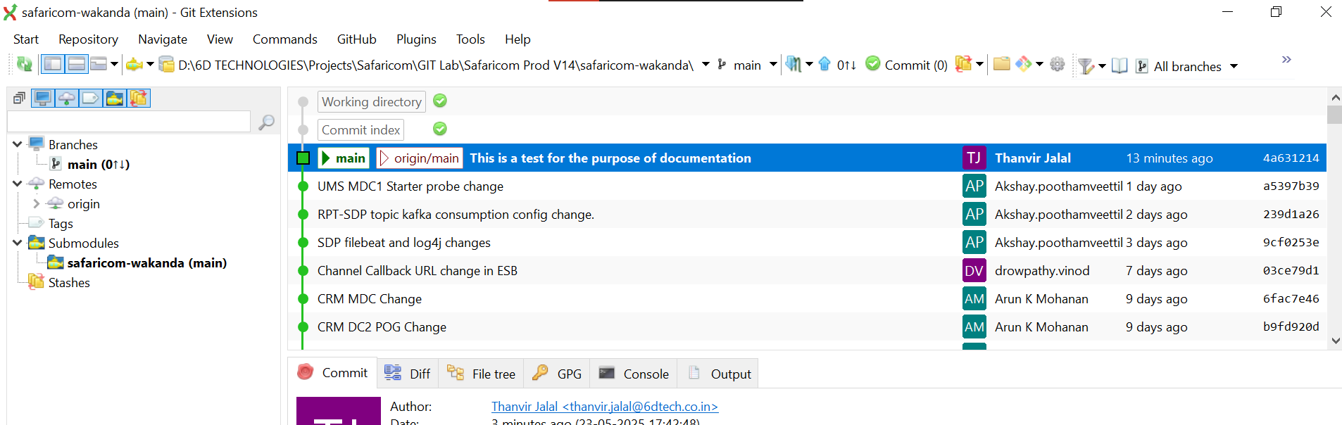

L2 Image Retrieval and Internal Registry Push
- Image Build & Push by L3

- L3 builds Docker images for updated UPC microservices.
- These images are tagged and pushed to a common Docker Hub repository.
- L3 shares:
- DockerHub image tag(s)
- Any updated configuration files (e.g., application.yaml, kustomization.yaml)

- Image Pull & Re-Publish by L2

- L2 logs into Docker Hub using pre-shared credentials.
- Pulls the shared image to the BP/Prod Jump servers.
- Tags and pushes the image to the internal Harbor registry in BP/Prod.

# Steps
- docker login -u " safaricoml2deploy " // Login to dockerHub

- docker pull thanvirjalal/upc-web-portal:v1.1.1-dev-498 // Pull image for dockerHub
- docker login -u "thanvir.jalal@blueprint.lab" registry.tools.blueprint.lab // Login to Harbor

- docker tag docker.io/thanvirjalal/upc-web-portal:v1.1.1-dev-498 registry.tools.blueprint.lab/bss/upc-web-portal/upc-web-portal:v1.1.1-dev-498 // Tag the image to Harbor

- docker push registry.tools.blueprint.lab/bss/upc-web-portal/upc-web-portal:v1.1.1-dev-498 // Push the image to Harbor

- Git Configuration Update by L2

- L2 updates the image field in the appropriate kustomization.yaml file in overlay of corresponding sites on VS Code.
- Also applies any configuration files (if shared by L3).
- Commits and pushes changes using the Git extension.

Sync via ArgoCD
Once Git changes are pushed, ArgoCD must be manually synced:
- Log in to ArgoCD
- EDC2 URL: https://argocd.bss2.safaricomet.net/login
- MDC1 URL: https://argocd.bss3.safaricomet.net/login
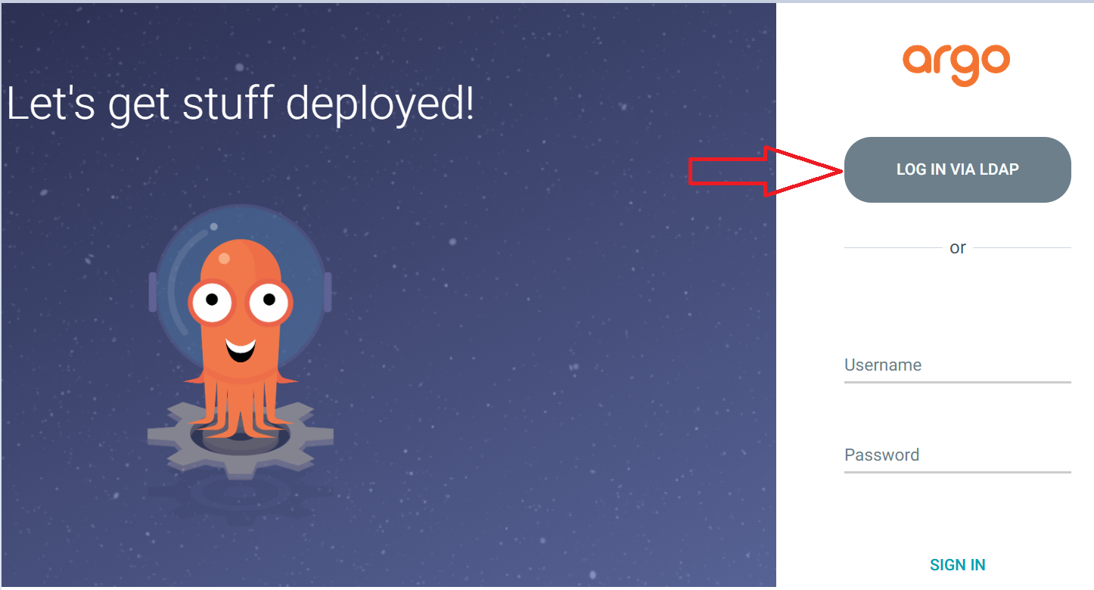
- Locate the Application
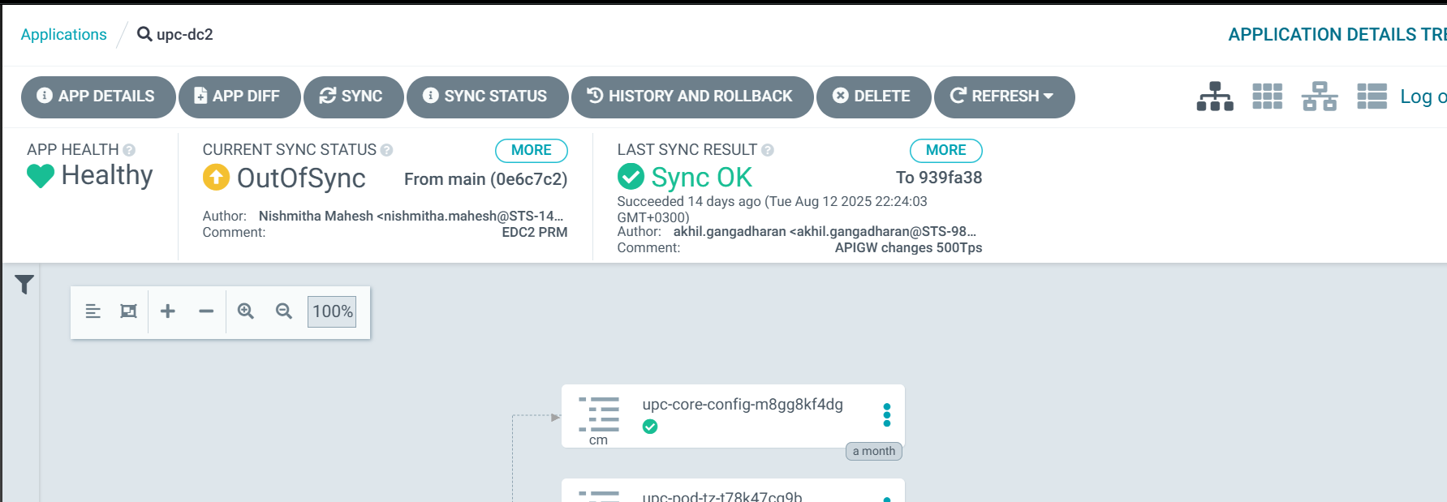
- Perform a Sync
- Click Refresh → Sync → Synchronize
- Enable “Prune” and “Prune Last” before Synchronize
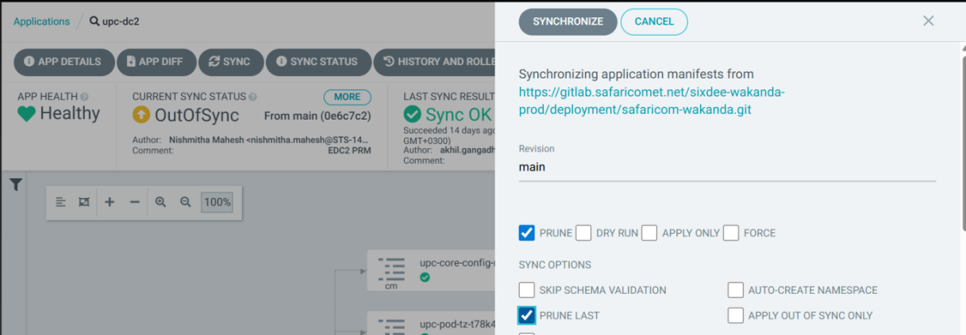

Validation After Deployment
After ArgoCD sync:
- Verify pods are updated:
kubectl get pods -n bss-prod-apps|grep upc

- Check logs or use:
kubectl logs <pod-name> -c <container>

- Confirm application endpoints are responding correctly via Ingress

Manual Git-Based Deployment (Fallback – Jump Server)
If ArgoCD is unavailable or unresponsive, deployment can be performed manually using the Git CLI on the jump server:
- Log in to Jump Server
ssh svc-bss-pam@xx-bss-jump01

- Clone or Update the Repo
cd /home/thanvir.jalal@safaricomet.net/gitsample/safaricom-wakanda

# If not cloned

git clone https://gitlab.safaricomet.net/sixdee-wakanda-prod/deployment/safaricom-wakanda.git

cd safaricom-wakanda

# If already cloned

git stash [Local-only action (saves your work aside, doesn’t touch remote)]
git pull [Remote-related action (brings others’ work into your branch)]
sudo chmod 777 /opt/safaricom-wakanda -R

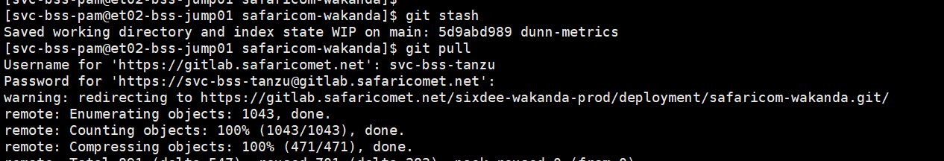

- Apply the Changes Manually
cd safaricom-wakanda/overlay/edge-dc2-cluster/upc

kubectl apply -k .
Deployment path In Blueprint Environment:
Cd /home/srinidhi-6d@blueprint.lab/safaricom-wakanda/overlay/blueprint-cluster/upc/

References and Access Details

Item | Value (MDC1) | Value (EDC2)
Git Repo (Prod) | https://gitlab.safaricomet.net/sixdee-wakanda-prod/deployment/safaricom-wakanda.git | https://gitlab.safaricomet.net/sixdee-wakanda-prod/deployment/safaricom-wakanda.git
Docker Hub | https://hub.docker.com/repositories/safaricoml2deploy | https://hub.docker.com/repositories/safaricoml2deploy
Harbor Registry | mdc1-sfcr.safaricomet.net | et02-harbor.safaricomet.net
ArgoCD URL | https://argocd.bss3.safaricomet.net/login | https://argocd.bss2.safaricomet.net/login
DockerHub Credentials | Will be shared with L2 via email | Will be shared with L2 via email
Harbor Credentials | AD Credentials | AD Credentials
ArgoCD Credentials | AD Credentials | AD Credentials

Logging, Monitoring, and Management
Logging and monitoring are critical components of the UPC application’s operational reliability. All application logs are stored on NFS-mounted directories to ensure centralized access, backup, and long-term retention.

Log Storage Overview
Each UPC pod (e.g., upc-core, upc-web-portal, cms-upc-web-portal) writes logs to a specific NFS-mounted directory. These logs are mounted to the Kubernetes containers at runtime using shared volumes.
- Logs are categorized per microservice and have persisted to NFS, allowing:
  - Centralized access from jump servers
  - Consistent backup and archiving
  - Separation of logs by pod and container type

Accessing Logs from Jump Servers
Site | Jump Server Hostname | Mounted Log Path
MDC1 | mdc1-linuxjump01 | NFS mount to BSS_App_Data/bss-nfs-log/UPC/
DC2 | dc2-linuxjump01 | NFS mount to /BSS_App_Data/bss-nfs-log/UPC

Microservices | Mounted Log Path from Jump Server
Upc-core | /BSS_App_Data/bss-nfs-log/UPC/ upc-core
upc-web-portal | /BSS_App_Data/bss-nfs-log/UPC/ upc-web-portal
cms-upc-cweb-portal | /BSS_App_Data/bss-nfs-log/UPC/ upc-web-portal

Log Backup and Housekeeping Script
A scheduled housekeeping script runs daily to:
- Move logs of previous days to a backup directory
- Archive them into .zip files
- Delete backup archives based on a defined retention period
Cron Schedule:
00 02 * * * /home/svc-bss-pam@safaricomet.net/OPS/Daily-HouseKeeping-Scripts/Daily-HouseKeeping-Scripts.sh

Note: This script is scheduled under the root user on DC2 jump server. It is a common script used for housekeeping of all BSS modules, not just UPC. Do not modify the script or configuration file directly without consulting the Onshore 6D L2 Team.
Back Storage Path:
Hostname | Server IP | Path
mdc1-bss-adb01 | 10.4.74.132 | /BSS_App_Data/bss-nfs-log/bkp_dir
et02-bss-jump01 | 10.3.124.21 | /BSS_App_Data/bss-nfs-log/bkp_dir

Current Log Retention Policy
As of now:
- All UPC service logs are retained for 5 days
- This is defined in the in_path.txt file used by the housekeeping script
- Retention days can be configured per service

Reason: Due to UPC’s consistent stability over the past 3 years, only 5-day logs are retained to optimize storage usage.

Monitoring and Alerting
Robust monitoring is essential for ensuring service uptime and proactive fault detection. While the Safaricom UPC deployment does not currently utilize a full observability stack (e.g., Prometheus + Grafana), basic health monitoring and auto-recovery mechanisms are in place.

Prometheus Metrics Endpoints
Each UPC microservice is instrumented to expose a metrics endpoint, which can be consumed by Prometheus or any compatible monitoring tool. These endpoints return live operational metrics such as request counts, response times, memory usage, and active threads.

Note: Although these endpoints are available, Grafana and Prometheus are not currently integrated into the Safaricom deployment. This can be enabled in future if advanced monitoring dashboards are required

Troubleshooting Guide
This section provides a structured approach for L2 engineers to diagnose, investigate, and resolve issues in the UPC application. It includes standard troubleshooting methodology, common scenarios, log tracking techniques, Kubernetes commands, and special considerations for NFS mount slowness.

General Troubleshooting Approach
SL.NO | Step | Action
1. | Reproduce the issue | Understand the user flow and trigger the problem (if safe).
2. | Identify affected service | Use logs or API context to pinpoint the pod/microservice.
3. | Check pod and logs | Use kubectl logs, NFS log path, or Prometheus metrics if available.
4. | Validate configuration | Review service, image tag, environment variables, and Git history.
5. | Analyse root cause | Identify time of failure, patterns, or errors.
6. | Perform safe action | Restart pods or sync ArgoCD if appropriate.
7. | Escalate to L3 if needed | Use the documented escalation process in Section 12.

Log Access Paths
Site | Jump Server Hostname | Mounted Log Path
MDC1 | mdc1-linuxjump01 | NFS mount to /bss-nfs-log/UPC/
DC2 | dc2-linuxjump01 | NFS mount to /bss-nfs-log/UPC/

Microservices | Mounted Log Path from Jump Server
upc-core | /BSS_App_Data/bss-nfs-log/UPC/upc-core
upc-web-portal | /BSS_App_Data/bss-nfs-log/UPC/upc-web-portal
cms-upc-web-portal | /BSS_App_Data/bss-nfs-log/ PC/cms-upc-web-portal

Log Analysis – Tracking Requests
Understanding how to trace and correlate UI and backend requests is essential for debugging user complaints, analysing failures, and verifying response flows.

Tracking GET Requests from 3rd Parties to upc-core
This section explains how to analyse upc-core and third-party logs to track GET requests.
Step 1: Identify the Request in the third-party system
- Get the requestId from the upstream system from where the request is coming.
- Navigate to upc-core logs with corresponding requestId to the GET request.
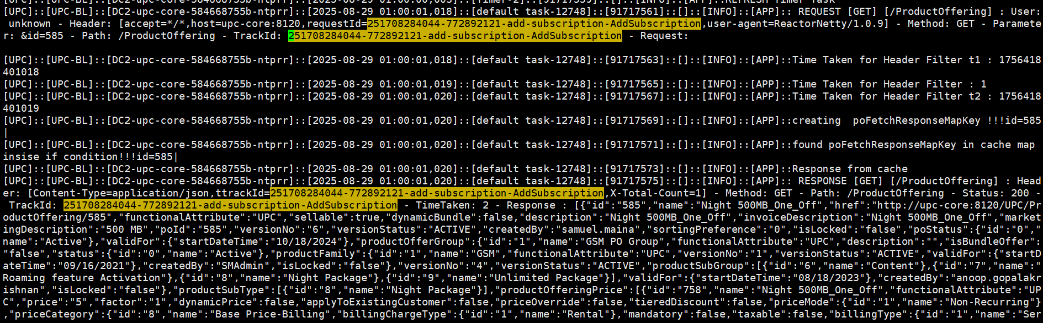
- From the above logs, it’s visible that the response from UPC taken from its cache. And from below entry in the upstream system shows that UPC response received.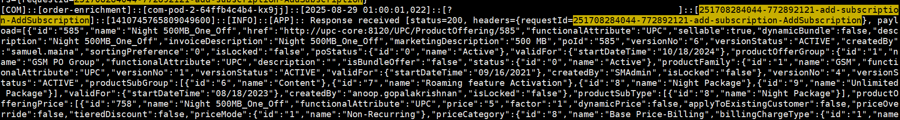

Step 2: Search for the Request ID in upc-web-portal/cms-upc-web-portal Logs
- Currently in both UI logs, we are not printing the request/transaction IDs

Common Kubernetes Troubleshooting Commands

Action | Command
Get pods | kubectl get pods -n bss-prod-apps
Describe a pod | kubectl describe pod <pod> -n bss-prod-apps
Tail logs | kubectl logs -f <pod> -n bss-prod-apps
Tail logs from a container | kubectl logs -f <pod> -c <container> -n bss-prod-apps
Restart deployment | kubectl rollout restart deployment <deployment> -n bss-prod-apps
Delete a pod | kubectl delete pod <pod> -n bss-prod-apps
Stop Application | Kubectl delete deployment deployment_name -n bss-prod-apps
Exec into container shell | kubectl exec -it <pod> -c <container> -n bss-prod-apps -- /bin/bash

12 UPC Unresponsiveness Due to NFS Mount Slowness
In the past, a frequent and critical issue was observed in the UPC platform where the application became unresponsive due to slow or blocked NFS mounts. These mounts are integral for:
- Writing application logs
This issue has since been mitigated following an NFS mount upgrade by the INFRA team. However, L2 should remain familiar with the symptoms and troubleshooting steps in case the problem resurfaces in the future.
Key Symptoms (If Issue Reappears):
- API returns timeouts
- Pods stuck in Running but non-responsive
- No log output written or log updates are delayed
- PODs restart repeatedly, especially those with log/CDR mounts (e.g., cm-api-services, cm-web-portal)
Why It’s Difficult to Detect
- NFS latency may not immediately crash the pod but can cause it to hang silently
- Standard kubectl logs or health check APIs may not show any errors
- Affected pods may show Running status while failing internally to write logs
- Other unrelated services may appear fully healthy

Isolation Strategy Based on Affected Modules:
Observed Behaviour | Likely Cause | Remarks
All UPC-like services are down, but Keycloak, Proxy, CRM-UI work fine | Likely log mount issue | These unaffected services do not depend on NFS log mounts
Only cm-pod-1, COM, UPC and SM-related services affected | Likely CDR mount issue | These services actively generate and flush CDRs
Repeated pod restarts across UPC | Pods not terminating properly as the mount path not releasing properly | Stale Log Mount
UPC not sending all parameters of a plan in response | Cache did not reload properly or manual change in the primary of cluster-2 where WKN_UPC database lies. | This can cause order failures/wrong order data creation. Restart of upc-proxy and upc-core application is needed.

Validation Commands for L2
- Log into the Pod and Manually Check the Mounts
kubectl exec -it <pod-name> -c <container-name> -n bss-prod-apps -- /bin/bash

- Check Mount Responsiveness via CLI:
ls -lrth /BSS_App_Data/bss-nfs-log/UPC/upc-core

- If the command hangs, NFS is likely blocked
- If only UPC paths hang, it's a UPC-specific NFS issue
- Verify Affected Pods:
kubectl get pods -n bss-prod-apps

- Restart the Pod (if confirmed safe):
kubectl rollout restart deployment deployment_name -n bss-prod-apps

- Check logs write behaviour:
tail -f /BSS_App_Data/bss-nfs-log/UPC/upc-core/ DC2-upc-core-<variable>_UPC_BL.log

Escalate to Infra if:
- You observe hangs when accessing NFS from the pod or jump server
- Pod continuously restarts after deletion
- Logs are not written, and multiple apps are impacted
- Timeout persists beyond 10–15 minutes
Attach evidence like ls command output (or hang), list of affected services, pod restart count, and NFS path involved when escalating.

Steps to take Heap & Thread Dump
Heap and thread dumps are essential for diagnosing memory leaks, GC issues, stuck threads, and performance bottlenecks in UPC Java-based services. These dumps can be analysed using tools such as Eclipse MAT, VisualVM, or Thread Dump Analyzer.
Applicable To:
- Java services running in UPC pods (e.g., upc-core, upc-web-portal, cms-upc-web-portal etc.)
- Typically needed when:
- There’s high memory usage
- Pod restarts frequently due to OOM
- Threads hang or service response is delayed

Heap Dump Collection
- Exec into the container:
kubectl exec -it <pod-name> -c <container-name> -n bss-prod-apps -- /bin/bash

- Find the Java process ID:
ps -ef | grep java

- Go to the log path
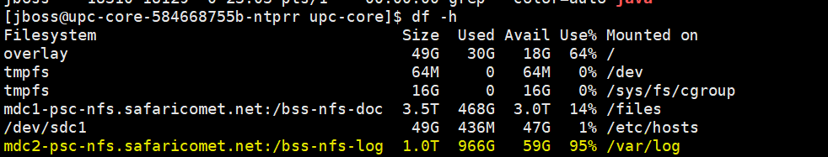
- Take a heap dump using jmap:
jcmd pid GC.heap_dump log_path/upc-core-heapdump.hprof

- The dump will be saved to the same NFS-mounted log directory (e.g., /var/log) and is immediately accessible via the jump server without the need to use kubectl cp.

Thread Dump Collection
- Exec into the container:
kubectl exec -it <pod-name> -c <container-name> -n bss-prod-apps -- /bin/bash

- Find the Java process ID:
ps -ef | grep java

- Navigate to the log directory of the application
- Generate a thread dump:
Using jstack:
jstack <java-pid> > upc-thread-dump.txt

Using jcmd:
jcmd <java-pid> Thread.print > upc-thread-dump.txt

- Access the thread dump from the jump server

Best Practices:
- Take multiple thread dumps at 10-second intervals to analyse blocked threads and deadlocks.
- Label the dump files with pod name and timestamp.
- Avoid taking dumps during high-traffic periods unless necessary.

Operational Tasks
The UPC platform is relatively stable and requires minimal day-to-day operational intervention.
However, we have an alert script which is in place for checking the connection issues between the application and the database. This script will run on every minute to check in the logs whether we have any “Communications link failure”, if so, script will initiate the alert mail.
*/1 * * * * /bin/bash /home/svc-bss-pam@safaricomet.net/OPS/UPC-Monitoring/UPC-Monitoring.sh
Note: Script is scheduled to run in both sites during every one-minute interval

Below are the manual operation tasks that the UPC L2 team should handle. For each new requirement involving integration or configuration on the UPC side, the responsible L2 team member should either update their respective module or share the information with the relevant module owner to update their system.

4.1 BS CATEGORY MASTER Manual Data Addition
Whenever a new category is introduced in the UPC system, it must be added to this table with its corresponding category ID. The BS_CATEGORY_MASTER table of Case Management application defines customer or business segment categories within the BSS ecosystem. This mapping ensures alignment across systems and supports accurate classification and reporting.
Table name: BS_CATEGORY_MASTER [Database: WKN_CM]
INSERT INTO `BS_CATEGORY_MASTER` (`CATEGORY_ID`, `CATEGORY_NAME`, `CREATE_DATE`) VALUES ('11', 'Large Enterprise LE', '2023-07-13 23:29:55');

4.2 bs_service_offering_master Manual Data Addition
Whenever a new POG [product offer group] is introduced in the UPC system, it must be added to this table with its corresponding group name. The bs_service_offering_master table of Billing System application defines customer or business segment categories within the BSS ecosystem. This mapping ensures alignment across systems and supports accurate classification and reporting.
Table name: bs_service_offering_master [Database: WKN_BILL]
INSERT INTO `bs_service_offering_master` (`serv_offering_id`, `serv_offering_desc`, `create_user`, `create_date`, `update_date`, `update_user`, `status`) VALUES (1, 'BIA', NULL, '2024-03-20 02:58:30', '2024-03-20 02:58:30', NULL, 1);

4.2 SLM_GENERAL_DROP_DOWN_DETAILS Manual Data Addition
Whenever a new POG [product offer group] is introduced in the UPC system, it must be added to this table with its corresponding group name. The SLM_GENERAL_DROP_DOWN_DETAILS table of SLM application defines customer or business segment categories within the BSS ecosystem. The ID in this query should be the same as the POG_ID in the UPC system. This mapping ensures alignment across systems and supports accurate classification and reporting.
Table name: SLM_GENERAL_DROP_DOWN_DETAILS [Database: WKN_SLM]
INSERT INTO `SLM_GENERAL_DROP_DOWN_DETAILS` (`SEQ_ID`, `CREATED_DATE`, `CREATED_USER`, `ID`, `VALUE`, `TYPE`, `LANGUAGE_ID`, `MODIFY_DATE`, `MODIFY_USER`, `MVNO_ID`, `STATUS`) VALUES ('011fcdc8-e7a2-4add-b094-1c1d8e0c3f91', '2023-11-17 13:34:44', '1', '81', 'AirFiber Business Internet', 'OFFERING_TYPE_4', '1', '2024-07-06 05:20:03', '1', '200', '1');
INSERT INTO `SLM_GENERAL_DROP_DOWN_DETAILS` (`SEQ_ID`, `CREATED_DATE`, `CREATED_USER`, `ID`, `VALUE`, `TYPE`, `LANGUAGE_ID`, `MODIFY_DATE`, `MODIFY_USER`, `MVNO_ID`, `STATUS`) VALUES ('011fcdc8-e7a2-4add-b094-1c1d8e0c3f92', '2023-11-17 13:34:44', '1', '82', 'AirFiber Dedicated Internet', 'OFFERING_TYPE_4', '1', '2024-07-06 05:20:33', '1', '200', '1');

Note: SEQ_ID can be an alphanumeric value [example: 011fcdc8-e7a2-5add-d094-1c1d8e0c3f99]

4.3 Channel Configuration
Whenever a new Channel needs to be configured in the BSS system, it needs to be created from the UPC UI. Then the same have to share with the other L2 member along with the “Channel Name” and “Channel ID”, so that they can add it in the downstream system.
To verify whether the configuration is fine, check in the table.
- UPC_META_DATA_DETAILS_MASTER
[SELECT * FROM `WKN_UPC`.`UPC_META_DATA_DETAILS_MASTER` WHERE METADATANAME='CHANNEL']

L2-to-L3 Escalation Procedure and SLA Guidelines

Purpose
To formalize the communication and escalation workflow from L2 to L3, ensuring clarity, completeness, and traceability of escalated issues.

Escalation Workflow

L2 Diagnosis
The L2 team performs preliminary investigation and fills the Safaricom L3 Escalation Template (attached below) with all required details:
- Issue summary and logs
- Reproduction steps
- Screenshots, DB entries, dumps (if applicable)
- Initial corrective actions
Safaricom L3 Escalation Template
Safaricom L3 Escalation Template Filled – Sample

Submit Escalation to 6d Support
Send the completed escalation template via email to:
Support Sixdee: [support@6dtech.co.in]
- Subject Format: [BSS Wakanda][UPC[L3 Escalation][P1-P4] <Short Description>
- Attach: Filled escalation template, logs, screenshots, etc.

L3 Assignment
The 6d Support team will:
- Acknowledge the mail
- Assign a designated L3 engineer
- Share a tracking reference or ticket ID

Template Verification
The assigned L3 engineer will:
- Review the submitted escalation template and attachments
- Either Accept or Reject the issue

Note: SLA countdown starts only after L3 formally accepts the escalation and confirms the details provided are complete and sufficient.

- If accepted, L3 will request any further data within the same email thread.
- If rejected, L3 will specify the missing or incomplete information. The L2 team must address the gaps and resubmit.

Prerequisites Before Escalation
L2 should ensure the following checks are complete:
- Logs analysed (application, terminal, DB, network)
- System health validated via monitoring tools
- Pod/service restart attempted (if safe)
- DB connection and config verified
- Thread/heap dump collected (for high memory/CPU issues)
- Steps to reproduce clearly documented
- Screenshots, logs, and traces attached

Incident Severity Classification (P1-P4)

Priority | Definition | Customer Impact | Response
P1 (Critical) | Complete outage or major service disruption. No workaround available. Immediate attention needed. | All customers affected | Immediate action
P2 (High) | Severe service degradation or partial outage. Temporary workaround available. | Large group (~30-50%) affected | Fast-track within business hours; workaround until permanent fix.
P3 (Medium) | Minor issue with limited impact. System/service still functions with minor inconvenience. | Small subset (~<10%) affected | Standard resolution timeline (next release or hotfix if needed)
P4 (Low) | Cosmetic/minor performance issues | No real customer impact | Track for future patch/release; no immediate fix required

Ticket Hold & Auto-Closure Policy
- If L2 fails to respond to an L3 query or fix verification within 3 calendar days, the ticket will be moved to On-Hold status.
- If there is still no reply even after 7 days (four days after holding the ticket), the L3 team will close the ticket.
- If needed, L2 can open a new escalation with updated details referencing the original ticket.

Post-Escalation Handling
Once L3 accepts the escalation:
- They will provide RCA, interim workaround (if available), and ETA for resolution.
- Further data will be requested in the same mail chain.
- Fix validation and feedback to be coordinated jointly with L2.
- Resolution steps must be documented by L2 in internal knowledge base.

Appendices

API Request & Response Reference
This section provides reference details for API integrations with the Unified Product Catalogue (UPC) system. It includes the request and response structures, key field descriptions, and example payloads for commonly used GET and POST endpoints.

Fetch Family details
Method: GET
Endpoint:
curl --location 'https://{url}/UPC/ProductFamily'

View all language mapping of plans
Method: GET
Endpoint:
curl --location 'https://{url}/UPC/POLanguage'

View all language mapping against the plan IDs

Method: GET
Endpoint:
curl --location 'https://{url}/UPC/ProductOffering?id=118&language=2'

Query Parameters:
keyword: id (e.g., 118= Consumer Pre-pay base plan)
Language: id (e.g., 2=amharic)

Fetch details with Product ID
Method: GET
Endpoint:
curl --location 'https://{url}/UPC/ProductOffering?id=118'

Query Parameters:
- keyword: ID (e.g., 118)

Fetch plans with Filters and Parameters
Method: GET
Endpoint:
curl --location 'https://{url}/UPC/ProductOffering?productSpecifications.type.id=2&productFamily.id=1&productOfferGroup.id=1&productSubGroup.id=9' \
--header 'ConnectionType: 2' \
--header 'customerprofiletype: 1' \
--header 'serviceType: 3' \
--header 'Channel: 3' \
--header 'Frequency: 4' \
--header 'Content: 9'

Query Parameters:
- productSpecifications.type.id: Addon/BasePlan (e.g., 1 or 2)
- productFamily.id: Filtering based on the product Family (e.g 1=gsm Family)
- productOfferGroup.id: Filtering based on the product offer group (e.g 1=gsm POG)
- productSubGroup.id: Filtering based on the product offer sub-group (e.g 9=unlimited)
Headers:
- ConnectionType: Connection Type Filter [e.g postpaid or prepaid]
- Content: Content type Filter [e.g Telegram, Facebook]
- Customerprofiletype: Profile type filter [e.g EBU or CBU]
- Channel: Channel filter [e.g CRM, USSD etc.]
- Frequency: Frequency filter [e.g Daily, Weekly, Monthly etc.]
- ServiceType: Service type filter [e.g Data, Voice, SMS etc.]

Please find the attached basic API collection currently in-hand regarding the UPC details fetches. You can enhance this by checking the logs.

APIs called from UPC

15.2.1 Towards NMS to Fetch shortcodes [refer logs for more info]:
Calling >>>http://nms-pod-two:8086/external-msisdn/Numberpool/v4/search?filterNumberType=4&filterCount=10&filterConnectionType=1&filterCustomerType=1&filterCategoryId=7

15.2.2 Towards Mo-Router to Insert the SDP plan details [refer logs for more info]:
{"request":{"request_timestamp":"20250910114845","source_system":"UPC","user_name":"***","service_configuration":[{"keyword":"AS","offercode":"39444010030","oprationCode":"SUBSCRIPTION","shortcode":"4401","cpId":"440","id":"39444010030_1"}],"action":"create","request_id":"1757494125085","status":"1"}}
Note: URL is not printing in the application logs

PO Creation Flow
This session explains the Product offer creation flow in the UPC/SDP system.
Note: This is basic information as this flow can change depending on the requirements from the Safaricom side.
The below diagram demonstrates the steps that are associated in the PO creation process. Here we have separated the PO creation process into 3 steps for better understanding.
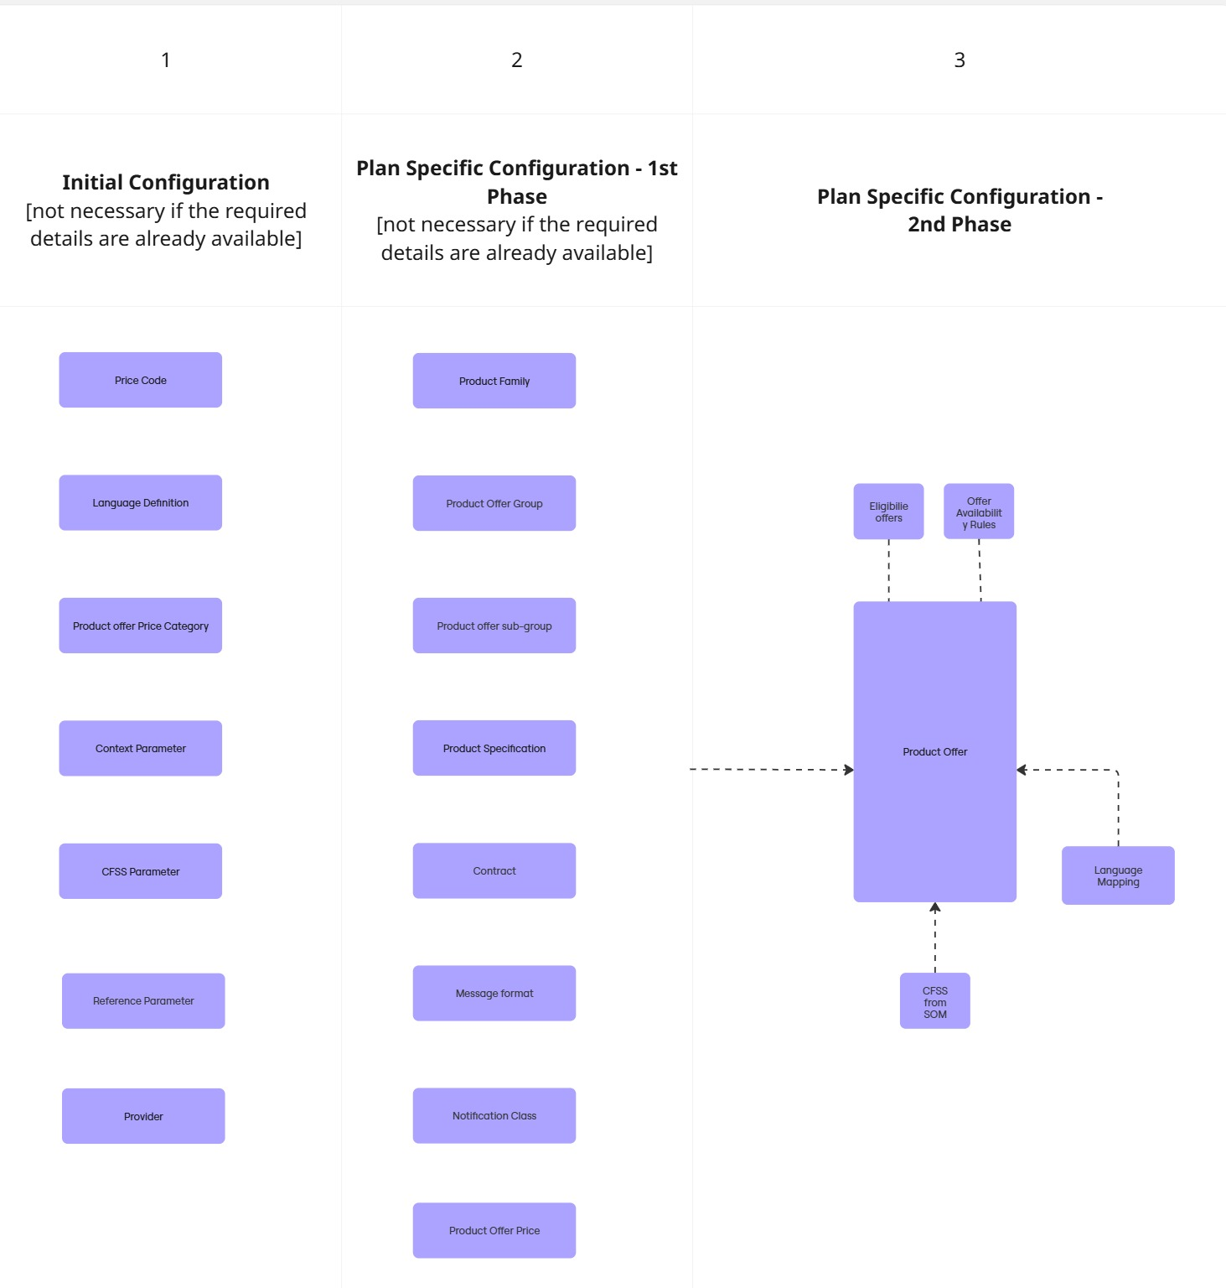

Step 1:
- Price Code: Creating a price code is a mandatory step in PO creation. Without a price code, users will not be able to create a product offer price. Note: A price code does not need to be created for every PO request; typically, this is a one-time configuration unless a new requirement arises.

- Language Creation: Language creation is a mandatory configuration in UPC. It defines the languages in which notifications and plan descriptions should be configured.

- Product Offer Price Category: Price category creation is used to classify products based on business requirements and to meet conditions applied by other applications, such as SM. (For example, SM uses the price category for handling different actions, especially for FTTH services.)

- Context Parameter: Context parameters are values configured as key filters in plan fetch rules, such as Frequency, Channel, and Content, based on business requirements.

- CFSS Parameter: CFSS (Customer Facing Service Specification) parameters define customized values in a plan, which are required by downstream systems to take appropriate actions. New characteristics can be added to CFSS based on upstream requirements or business needs.

- Reference Parameter: Reference parameters support the configuration of new value additions or child activities. For example, a new POPType can be added as a reference parameter, which can then be used while creating a new price category.
- Provider: Providers are configured based on business requirements, i.e., creating new Service Providers (SP) and Content Providers (CP).
  - For SPs, we can specify the APIs they can access and the shortcodes allowed.
  - For CPs, we can specify allowed APIs, API credentials (username and password), shortcodes, and callback URLs.

Step 2:
- Product Family (PF): This is a mandatory configuration used to define new product family categories (e.g., GSM, MPESA, Fixed Data) based on business needs. These can be considered as network types.

- Product Offer Group (POG): POGs are groups created under a Product Family, and this is also a mandatory configuration.
- Product Offer Sub-Group (Sub-POG): Sub-POGs are used to differentiate categories within POGs. They are not mandatory but can be attached to specific POGs based on business requirements. Sub-POGs are configured under Reference Parameters.

- Product Specification (PS): PS defines the key parameters for a product. While creating a PS, we select whether it is an add-on/base plan and determine if plan details need to be shared with third-party systems like HLR, NCC, etc.
- Contract: Contracts can be defined if there are contractual charges required by business needs. These can be set on a monthly basis, with contract expiry configured either for automatic expiration or manual cancellation.

- Message Format: Message formats are not mandatory. However, if notifications are required for products configured in UPC, message formats must be created and attached to Notification Classes.

The current available place holder details attached below,
- Notification Class: Notification classes are configured to send notifications based on product requirements. Here we can specify:
  - The event that triggers the notification.
  - The operation for which the notification should trigger.
Messages can be configured with rules needed by downstream systems. For example, if a notification is created under the rule “Reminder”, then the SM application will pick up reminder notifications that meet this rule.

- Product Offer Price (POP): Prices are configured in UPC to be attached to products. These prices are shared along with other plan details in fetch requests, helping the requesting system identify product pricing. Currently in Safaricom, POP Type: Adhoc,CartLevel is not used. Different types of prices can be configured:

  - Static Prices: Fixed prices that do not change.
  - Dynamic Prices: Prices that change based on applied conditions.
Additionally, pricing strategies can specify whether a plan is recurring or non-recurring. POPs can also include tier-based pricing. For example:
  - SMS Plan: 1–10 SMS = 10 Birr; 11–100 SMS = 20 Birr.

In Safaricom, we currently support three tier types — Duration, Volume, and Period — which are considered as the units for Voice, SMS, and Data. These can be configured as per requirements.

Step 3:
- Eligible Offers Addition: Configuring eligible offers defines which plans are associated with specific eligibility conditions. For example, if a customer wants to purchase a data bundle, that bundle must first be added to the customer’s base plan as an eligible optional offer. Only then will the customer be able to purchase the bundle.
In Safaricom, the following conditions are applicable currently:
- Optional Offers
- Mandatory Offers
- Mutually Exclusive Offers
- Upgrade Offers
- Downgrade Offers

- Offer Availability Addition: This configuration applies filters on plans, guiding UPC to provide a plan only if the request satisfies all defined filter conditions.
- If a plan has no availability rules, UPC will return that plan for all requests.
- If availability rules are defined and even a single condition is not met, UPC will not return the plan details.
- Product Offer (PO) Creation: This is a key step where the user creates the Product Offer by specifying the following details:
- PO Name: A unique value (no duplicates allowed).
- PO Group.
- SP and CP (optional; required for VAS plans).
- PO Sub-Group (optional).
- Billing Description: Shown on invoices.
- UPC Description (optional).
- Marketing Description: Used by third parties.
- Product Specification: Defines product characteristics and type.
- Contract (optional).
- Start Date: When the plan becomes available.
- Is Sellable: Indicates if the product is available for sale.
- Eligible Offers (optional; attach if needed).
- Availability Rules (optional).
- Attach POP.
- Provide all required Plan Characteristics.

- Language Mapping Configuration: After completing product configuration, language mapping must be set for the Marketing Description and PO Name against the Product Offer. This ensures UPC responds with details in the correct language based on the language ID received in the plan fetch request.
If no specific language mapping is configured, UPC will return the default PO name and Marketing Description provided during PO creation.
Note: For SDP VaS plans, there are two additional calls from UPC to other systems. One is towards NMS for fetching shortcodes; the second call is towards Mo-Router to add entries regarding the plan keywords in the Mo-Router side.

Important Plan Characteristics
We add Product Specifications to a plan to define its behaviour and the key attributes that downstream systems can validate and process accordingly. The plan characteristics play a crucial role in plan configuration, as the plan’s behaviour is determined by the keys attached under these characteristics.
By default, a standard BSS plan typically includes CFSS_UPC and CFSS_NCC characteristics. However, this can vary based on requirements. For example, if a plan should not trigger any NCC calls, the CFSS_NCC characteristic can be omitted.

CFSS_UPC:
- AllowedQuantity: Number of times a plan can be purchased. (Default = 0; means unlimited purchases. Mandatory field.)
- ComCallRequired: This is to notify the SM application if the SM needs to initiate a call towards COM; [Optional field – add if required].
- GIFTING_ACTIVATION_COUNT: This count is needed by the COM application to apply validation based on the gifting count done by the A-party [Specifies the number of gifting operations allowed per MSISDN within a calendar month- only for FTTH now – refer ADM HLD for more details]. (Optional field; add if required.)
- IsPreRenewal: Indicates whether the SM application should initiate a pre-renewal notification. (Optional field; add if required.)
- MarginBasePlan: Defines if the base plan margin is Positive or Negative since we have a concept of creating both Positive and Negative margin base plans. (Default = Positive; optional field.)
- MultipleSubscriptionAllowed: Restricts customers from purchasing the plan a second time while the first one is still active. (Default = true; mandatory field, configurable as required.)
- NotificationClass: Notification class attached if notifications need to be initiated by the SM application. (No default; optional field.)
- OfferCategory: Defines whether the plan belongs to BSS or SDP. (Mandatory field; must be specified according to the plan type.)
- PackageType: Type of package being configured whether it’s normal plan or HLR plan or VaS plan. (Default = 21 (IN); optional field.) [Not in use for Safaricom- please keep the default value for all plans]
- REQUIRED_CHILD_SERVICES: Defines the POG of child services that a primary service must have in order to be eligible to purchase the corresponding plan [only for FTTH now – the value configured is the network type of FTTH – refer ADM HLD for more details]. (Optional field; add if required.)
- ServiceType: Defines the type of service provided in a bundle (e.g., Data / Voice / SMS / Combo). (No default; configurable as required.)
- SKU_CODE: Code sent to SnD, mostly used for device plans. (No default; configurable as required.)
- SubscriptionType: Defines the type of subscription (e.g., Subscription, Promotional, On-demand). (Default = 10 (Subscription); optional field.)

CFSS_NCC:

- ELIGIBLE_FOR_TRANSFER: This is an account level custom data which COM refers, please reach to NCC for more details as BSS does not have any logic based on this value. (optional field)
- EXTERNAL_OFFER_ID: Here we are providing the NCC_ID of the plan where we can use a key identifier while sending the request towards NCC. (mandatory field)
- DATAOOBFLAG: This can be set based on the requirement. This value is a device level custom data which COM refers, please reach to NCC for more details as BSS does not have any logic based on this value. (optional field)
- SUBSCRIBERTYPE: This can be set based on the requirement. This value is a device level custom data which COM refers, please reach to NCC for more details as BSS does not have any logic based on this value. (optional field)
- RECHARGE_OPTIONS: This can be set based on the requirement. This value is a device level custom data which COM refers, please reach to NCC for more details as BSS does not have any logic based on this value. (optional field)

The above characteristics are for BSS plans, but the below one is specifically for SDP plans.

CFSS_SM_STD:

- ActivationKeyword : Define which keyword can be used for plan activation (optional field). – [not required for On-demand offers]
- ChargingSystem : Defines from where the balance should be deducted (mandatory field; usually Airtime).
- ConsentKeyword : Defines which keyword can be accepted when consent response is received from subscriber (optional field).
- ConsentShortcode : Defines to which shortcode the consent request should be sent (optional field). [not required for On-demand offers]
- CPNotification : Whether to initiate a CP notification (optional field).
- DeactivationKeyword : Define which keyword can be used for plan deactivation (optional field). [not required for On-demand offers]
- DefaultCallBack : The callback URL that needs to be specified (optional field).
- InteractiveFlag : To identify whether the plan is interactive or non-interactive (optional field).
- InteractiveShortcode : Shortcode to be specified if the plan is interactive (optional field).
- IsPreRenewal : Indicates whether the system should initiate a pre-renewal notification (optional field; add if required).
- IsRenewal : Indicates whether the system should initiate stop-renewal notifications and deactivate one-off plans in the SDP application (optional field).
- NotificationClass : Notification class attached if notifications need to be initiated by the SM application (optional field; no default).
- PaymentConsent : Needs to be enabled if the plan requires payment consent (optional field).
- PaymentConsentOnChannels : Channels on which payment consent is required (optional field).
- PaymentSynchChannels : Channels for synchronous payment (optional field).
- PaymentUssdConsentEnabledOnChannels : Channels where USSD-based payment consent is enabled (optional field).
- RatePlanType : Defines the plan type, such as normal plan or promotional plan (optional field).
- RequestSMSConsentEnabled : Needs to be enabled if the plan requires SMS consent (optional field).
- RequestSMSConsentOnChannel : Channels for SMS-based request consent (optional field).
- RequestSMSSynchChannels : Channels for synchronous SMS request consent (optional field).
- RequestSMSUssdConsentEnabledOnChannels : Channels where USSD-based request consent is enabled (optional field).
- ShortCode : Defines through which shortcode the plan-related requests are received (mandatory field).
- SubscriptionConsent : Needs to be enabled if the plan requires subscription consent (optional field).
- SubscriptionConsentOnChannels : Channels for subscription consent (optional field).
- SubscriptionSynchChannels : Channels for synchronous subscription consent (optional field).
- SubscriptionUssdConsentEnabledOnChannels : Channels where USSD-based subscription consent is enabled (optional field).
- ussdNIPUSHDisplay : Message ID for USSD push notification to be displayed (optional field).
- ussdNIPUSHShortCode : Shortcode to which the NI push should be delivered (optional field).

